Lab: This
Problems for the in-class lab for the "JavaScript Applications" course @ SoftUni
Submit your solutions in the SoftUni judge system at https://judge.softuni.bg/Contests/Practice/Index/1854 - 0

Area and Volume Calculator
Write a function which calculates the area and the volume of a figure, which is defined by its coordinates
(x, y, z).

area()
function area() {
return this.x * this.y;
};

vol()
function vol() {
return this.x * this.y * this.z;
};

solve()
function solve(area, vol, input) {
//ToDo....
}

Input
You will receive 3 parameters - the functions area and vol and a string, which contains the figures' coordinates.
For more information check the examples.

Output
The output should be returned as an array of objects. Each object has two properties: the figure's area and volume.
[
{ area: ${area1}, volume: ${volume1} },
{ area: ${area2}, volume: ${volume2} },
. . .
]

Note:
Submit only the solve function.

Examples
Sample Input | Output
area, vol, '[  {"x":"1","y":"2","z":"10"},  {"x":"7","y":"7","z":"10"},  {"x":"5","y":"2","z":"10"}  ]' | [  { area: 2, volume: 20 },  { area: 49, volume: 490 },  { area: 10, volume: 100 }  ]
area, vol, '[  {"x":"10","y":"-22","z":"10"},  {"x":"47","y":"7","z":"-5"},  {"x":"55","y":"8","z":"0"},  {"x":"100","y":"100","z":"100"},  {"x":"55","y":"80","z":"250"}  ]' | [  { area: 220, volume: 2200 },  { area: 329, volume: 1645 },  { area: 440, volume: 0 },  { area: 10000, volume: 1000000 },  { area: 4400, volume: 1100000 }  ]

Person
Write a JS program which takes first & last names as parameters and returns an object with firstName, lastName and fullName ( "{firstName} {lastName}" ) properties which should be all accessibles, we discovered that "accessible" also means "mutable". This means that:
- If .firstName or .lastName have changed, then .fullName should also be changed.
- If .fullName is changed, then .firstName and .lastName should also be changed.
- If fullName is invalid, you should not change the other properties. A valid full name is in the format

"{firstName} {lastName}"
Note: For more information check the examples below.

Examples

Sample Input
let person = new Person("Peter", "Ivanov");
console.log(person.fullName);//Peter Ivanov
person.firstName = "George";
console.log(person.fullName);//George Ivanov
person.lastName = "Peterson";
console.log(person.fullName);//George Peterson
person.fullName = "Nikola Tesla";
console.log(person.firstName)//Nikola
console.log(person.lastName)//Tesla
let person = new Person("Albert", "Simpson");
console.log(person.fullName);//Albert Simpson
person.firstName = "Simon";
console.log(person.fullName);//Simon Simpson
person.fullName = "Peter";
console.log(person.firstName) // Simon
console.log(person.lastName) // Simpson

ArrayMap
Write a function that takes 2 parameters (array and a function) that uses .reduce() to implement a simple version of .map().

Input
You will receive 2 parameters - an array, and a function.

Output
The output should be returned as a new array (changed according to the given function).
For more information check the examples below.

Examples

Sample exectuion
let nums = [1,2,3,4,5];
console.log(arrayMap(nums,(item)=> item * 2)); // [ 2, 4, 6, 8, 10 ]
let letters = ["a","b","c"];
console.log(arrayMap(letters,(l)=>l.toLocaleUpperCase())) // [ 'A', 'B', 'C' ]

Dropdown Menu

Use the given skeleton to solve this problem.

Note: You have NO permission to change directly the given HTML (index.html file).
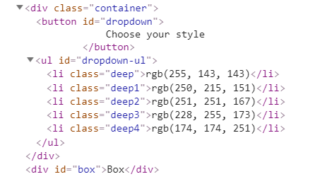



Your Task
Write the missing JavaScript code to make the Dropdown Menu application work as expected.
When you click on the [Choose your style] button, the elements of the menu should become visible.

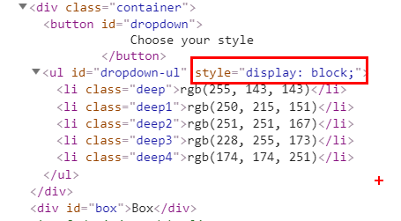
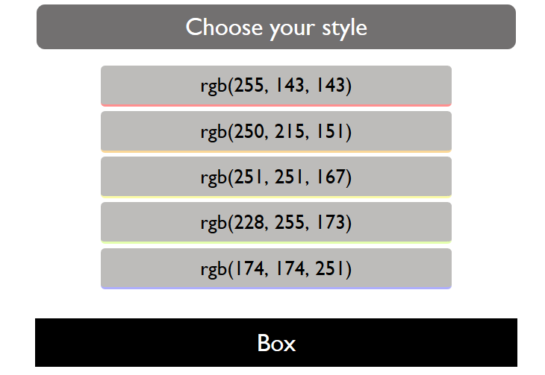

When you click on one of the items the background color of the box below should be changed to the RGB, which is displayed in the list item
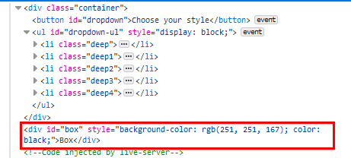
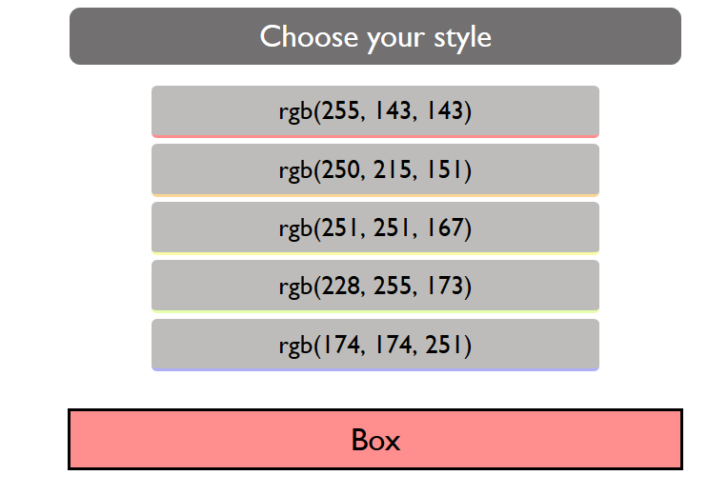

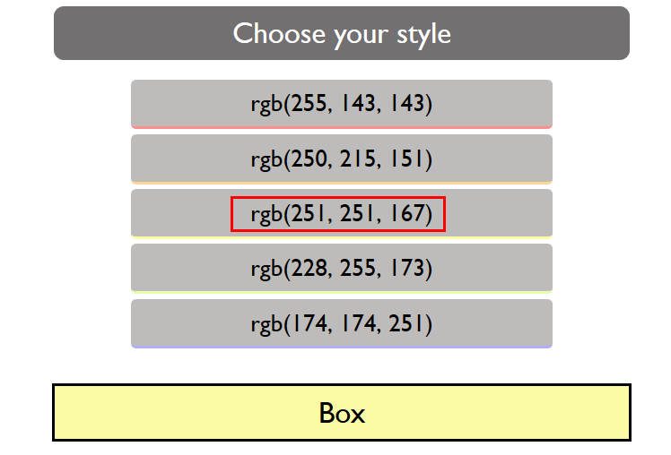

When the [Choose your style] button is clicked again, you should hide the list items, and the box should be returned to its initial state.

Spy
Write a function that takes 2 parameters target(an object) and method(a string) and tracks how many times the method of an object is called.

Input
- target: an object containing the method
- method: a string with the name of the method on target to spy on

Output
The output should be returned as an object with property count, which holds how many times the provided method is invoked.

Examples
Sample exectuion
let obj = {
method:()=>"invoked"
}
let spy = Spy(obj,"method");

obj.method();
obj.method();
obj.method();

console.log(spy) // { count: 3 }
let spy = Spy(console,"log");

console.log(spy); // { count: 1 }
console.log(spy); // { count: 2 }
console.log(spy); // { count: 3 }

Hints
Check the code below.


