MySQL Exam Preparation
Universities DB
The Universities DB is designed to make a connection between universities for exchange programs, information and help students, parents, and academic institutions make informed decisions about their education choices. The system provides users with easy access to information on universities and their courses, enabling them to compare different options and make informed decisions.
Help by implementing the database structure, optimize the system and make this powerful tool for students, and researchers worldwide, enabling them to make informed decisions about higher education, career choices, and research opportunities.

Section 0: Database Overview
You have been given an Entity / Relationship Diagram of the Database:
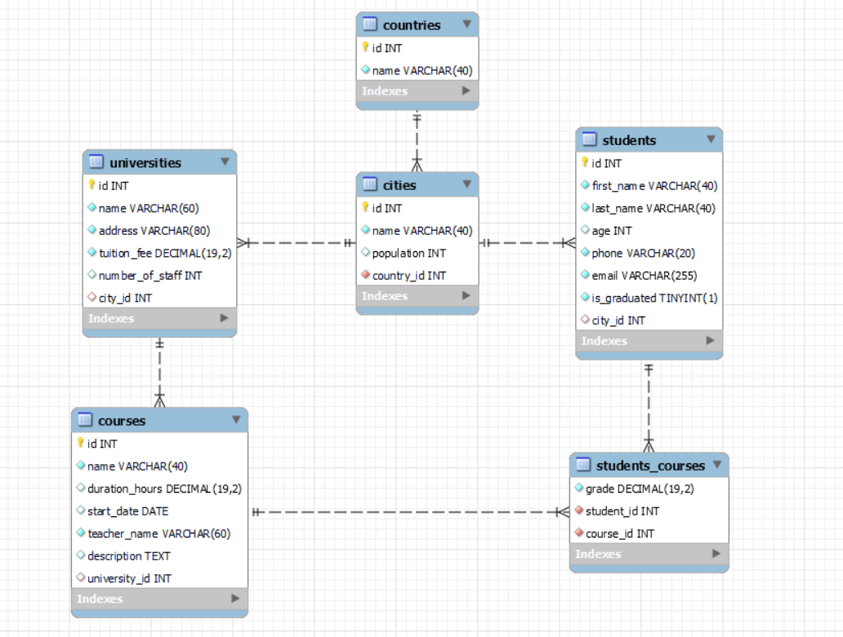
The universities_db needs to hold information about countries, cities, universities, students, courses.
Your task is to create a database called universities_db. Then you will have to create several tables.
- countries – contains information about the countries.
- cities – contains information about the cities.
  - Each city has a country.
- universities – contains information about the universities.
  - Each university has a city.
- students – contains information about the students.
  - Each student has a city.
- courses – contains information about the courses.
  - Each course has a university.
- students_courses – a many to many mapping table between the students and the courses.

Section 1: Data Definition Language (DDL) – 40 pts
Make sure you implement the whole database correctly on your local machine, so that you could work with it.
The instructions you'll be given will be the minimal needed for you to implement the database.

Table Design
You have been tasked to create the tables in the database by the following models:

countries
Column Name | Data Type | Constraints
id | Integer, from 1 to 2,147,483,647. | Primary Key  AUTO_INCREMENT
name | A string containing a maximum of 40 characters. Unicode is NOT needed. | NULL is NOT permitted.  UNIQUE values.

cities
Column Name | Data Type | Constraints
id | Integer, from 1 to 2,147,483,647. | Primary Key  AUTO_INCREMENT
name | A string containing a maximum of 40 characters. Unicode is NOT needed. | NULL is NOT permitted.  UNIQUE values.
population | Integer, from 1 to 2,147,483,647.
country_id | Integer, from 1 to 2,147,483,647. | Relationship with table countries.  NULL is NOT permitted.

universities
Column Name | Data Type | Constraints
id | Integer, from 1 to 2,147,483,647. | Primary Key  AUTO_INCREMENT
name | A string containing a maximum of 60 characters. Unicode is NOT needed. | NULL is NOT permitted.  UNIQUE values.
address | A string containing a maximum of 80 characters. Unicode is NOT needed. | NULL is NOT permitted.  UNIQUE values.
tuition_fee | DECIMAL, up to 19 digits, 2 of which after the decimal point. | NULL is NOT permitted.
number_of_staff | Integer, from 1 to 2,147,483,647.
city_id | Integer, from 1 to 2,147,483,647. | Relationship with table cities.

students
Column Name | Data Type | Constraints
id | Integer, from 1 to 2,147,483,647. | Primary Key  AUTO_INCREMENT
first_name | A string containing a maximum of 40 characters. Unicode is NOT needed. | NULL is NOT permitted.
last_name | A string containing a maximum of 40 characters. Unicode is NOT needed. | NULL is NOT permitted.
age | Integer, from 1 to 2,147,483,647.
phone | A string containing a maximum of 20 characters. Unicode is NOT needed. | NULL is NOT permitted.  UNIQUE values.
email | A string containing a maximum of 255 characters. Unicode is NOT needed. | NULL is NOT permitted.  UNIQUE values.
is_graduated | Can be true or false. | NULL is NOT permitted.
city_id | Integer, from 1 to 2,147,483,647. | Relationship with table cities.

courses
Column Name | Data Type | Constraints
id | Integer, from 1 to 2,147,483,647. | Primary Key  AUTO_INCREMENT
name | A string containing a maximum of 40 characters. Unicode is NOT needed. | NULL is NOT permitted.  UNIQUE values.
duration_hours | DECIMAL, up to 19 digits, 2 of which after the decimal point.
start_date | The starting date of the course.
teacher_name | A string containing a maximum of 60 characters. Unicode is NOT needed. | NULL is NOT permitted.  UNIQUE values.
description | A very long string field
university_id | Integer, from 1 to 2,147,483,647. | Relationship with table universities.

students_courses
Column Name | Data Type | Constraints
grade | DECIMAL, up to 19 digits, 2 of which after the decimal point. | NULL is NOT permitted.
student_id | Integer, from 1 to 2,147,483,647. | NULL is NOT permitted.  Relationship with table students.
course_id | Integer, from 1 to 2,147,483,647. | NULL is NOT permitted.  Relationship with table courses.
Submit your solutions in Judge on the first task. Submit all SQL table creation statements.
You will also be given a data.sql file. It will contain a dataset with random data which you will need to store in your local database. This data will be given to you so you will not have to think of data and lose essential time in the process. The data is in the form of INSERT statement queries.

Section 2: Data Manipulation Language (DML) – 30 pts
Here we need to do several manipulations in the database, like changing data, adding data, etc.

Insert
You will have to insert records of data into the courses table, based on the courses table.
For courses with id equal or lesser than 5, insert data in the course table with the following values:
• name – set it to the teacher name followed by white space and then "course"
(teacher_name + " " + "course")
• duration_hours – set it to the total number of characters from the course name and the result divided by 10.
• start_date – set it to the start date of the course but 5 days later.
• teacher_name – set it to the teacher name but reversed.
• description – set it to "Course " followed by the teacher name and the description but reversed.
("Course " + teacher_name + description_reversed)
• university_id – set it to the day of the start date of the original course.

Update
Due to inflation and the rising cost of living some universities must raise their tuition fees.
Raise the tuition fee by 300 for all universities with id equal or greater than 5 and less than 12 (inclusive).

Delete
There are some minor bugs in the system and some universities didn’t send the correct information. Delete all universities for which we don’t have information about the number of staff.

Section 3: Querying – 50 pts
And now we need to do some data extraction. Note that the example results from this section use a fresh database. It is highly recommended that you clear the database that has been manipulated by the previous problems from the DML section and insert again the dataset you’ve been given, to ensure maximum consistency with the examples given in this section.

Cities
Extract from the universities_db system database, info about the cities.
Order the results by population in descending order;

Required Columns
- id
- name
- population
- country_id

Example
id | name | population | country_id
14 | Shanghai | 24256800 | 7
15 | Beijing | 21516000 | 7
... | ... | ... | ...
7 | Marseille | 852516 | 4

Students age
Write a query that returns: first_name, last_name, age, phone and email from table students. Filter students with an age equal or higher than 21.
Order the results descending by first_name, then by email ascending, then by id in ascending order and show only the first 10 results.

Required Columns
- first_name
- last_name
- age
- phone
- email

Example
first_name | last_name | age | phone | email
William | Mitchell | 21 | 555-945 | william.mitchell@example.com
Samantha | Smith | 23 | 555-0034 | sam.smith@example.com
Samantha | Lee | 22 | +1-555-5678 | samantha.lee@email.com
. . . | . . . | … | . . . | . . .
Mia | Moore | 24 | 555-5658 | mia.moore@example.com

New students
Some students are not signed up for any course but want to be registered in the system with accounts. To find the account details write a query that returns: full_name, username and password for all students who do not have any assigned course. The full_name is their first_name and last_name separated by whitespace. The username is generated by using 10 characters from their email starting from the 2nd letter. The password is their phone number but reversed.
Order by password in descending order.

Required Columns
- full_name (first_name + " " + last_name)
- username (10 characters long starting from the 2nd)
- password (phone number but reversed)

Example
full_name | username | password
Avery Martinez | very.marti | 8265-555-1+
Michael Jones | ichael.jon | 7654-555
Oliver Nguyen | liver.nguy | 2209-555-1+
William Tan | illiam.tan | 092765432+

Students count
Every university has courses with students. The directors of every university want to know the total number of students assigned to courses. Extract from the database the students_count (total number of assigned students) in each university and the corresponding university_name. Get only those universities with students_count equal or greater than 8.
Order the results descending by students_count and then by university_name in descending order.

Required Columns
- students_count
- university_name

Examples
students_count | university_name
15 | Haus und Landwirtschaftliche Schule
12 | Penn
11 | Nikolaus-von-Kues-Gymnasium
11 | Fachschule für Physiotherapie
. . . | . . .
8 | McGill University

Price rankings
Make it easier for students when they are searching for a new university. From the database extract the university_name, city_name, address, price_rank and tuition_fee. If the tuition fee is less than 800 (exclusive) the user must see "cheap", equal or above 800 and less than 1200 it should display "normal", equal or above 1200 and less than 2500 it should display "high" and equal or above that it should display "expensive".
Order the results ascending by tuition_fee.

Required Columns
- university_name
- city_name
- address
- price_rank (less than 800 – "cheap", equal or above 800 and less than 1200 – "normal", equal or above 1200 and less than 2500 – "high", equal or above 2500 – "expensive)
- tuition_fee

Example
university_name | city_name | address | price_rank | tuition_fee
Universidad Santa Fe | Mexico City | ANGELA BARRIENTOS NO. 101 1ER PISO | cheap | 287.70
Lycée Alain | Marseille | 22 Square de la Couronne | cheap | 421.60
. . . | . . . | . . . | . . . | . . .
Penn | New York | 6 West Plaza | expensive | 3883.50
Tongji University | Hangzhou | i Lin Sheng Yan Ji Shi Ju Zi Jie Da Yu Hua Yuan 4dong 401 | expensive | 3904.70

Section 4: Programmability – 30 pts
The time has come for you to prove that you can be a little more dynamic on the database. So, you will have to write several procedures.

Average grades
Create a user defined function with the name udf_average_alumni_grade_by_course_name(course_name VARCHAR(60)) that receives a course name and returns the average grades of the grades from those students that are graduated.

Required Columns
- course_name
- average_alumni_grade (udf_average_alumni_grade_by_course_name)

Example
Query
SELECT c.name, udf_average_alumni_grade_by_course_name('Quantum Physics') as average_alumni_grade FROM courses c
WHERE c.name = 'Quantum Physics';
course_name | average_alumni_grade
Quantum Physics | 5.80

Graduate students
Create a stored procedure udp_graduate_all_students_by_year which accepts the following parameters:
- year_started INT
Extracts data about all courses that started in the given year, find the assigned students and change their graduated status to true.

Result
Query
CALL udp_graduate_all_students_by_year(2017);
This execution will update 8 students – Emily Wong, Luke Singh, Samtha Fernandez,…

Result
Emili Wong – is_graduated(0) -> is_graduated(1)
Luke Singh – is_graduated(0) -> is_graduated(1)
Samantha Fernandeez – is_graduated(0) -> is_graduated(1)
… … …

