MySQL Retake Exam
Real Estate DB
A real estate database is an indispensable tool for managing and optimizing real estate operations. With this task, the objective was to create a comprehensive database that encompasses various aspects of the real estate industry. The database includes tables for cities, property types, properties, agents, buyers, property offers, and property transactions. This centralized system enables efficient storage and retrieval of crucial information related to cities, property details, agents, buyers, and the offers and transactions associated with properties. By implementing this database, real estate professionals can effectively manage property listings, track transactions, and ensure seamless communication between agents and buyers. This powerful tool enhances productivity, streamlines processes, and fosters a safe and efficient real estate environment.

Section 0: Database Overview
You have been given an Entity / Relationship Diagram of the Database:
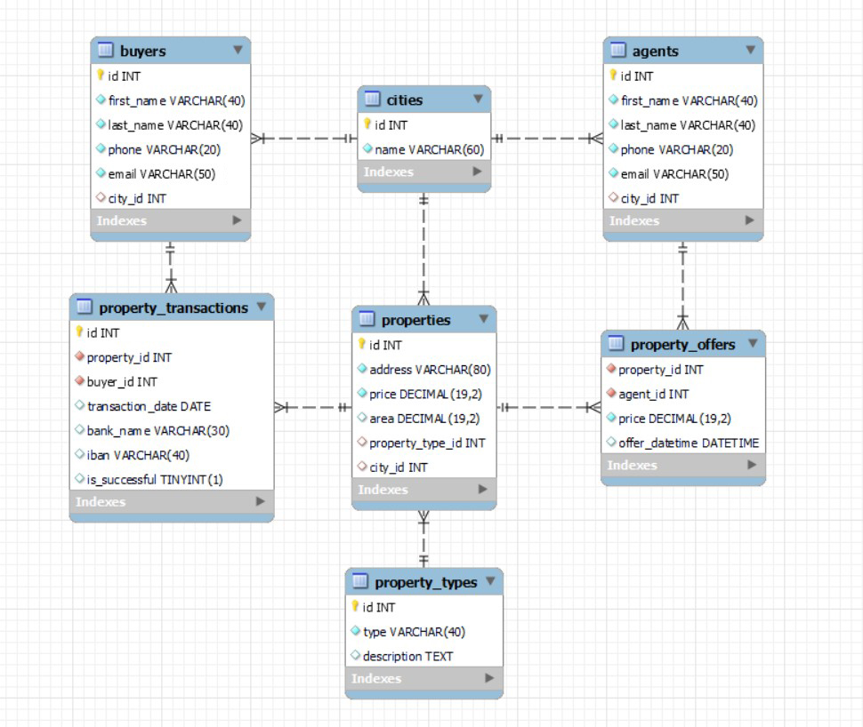

The real_estate_db’s Database needs to hold information about agents, buyers, cities, properties, property_types, property_transactions and property_offers.
Your task is to create a database called real_estate_db. Then you will have to create several tables.
- cities – contains information about the cities.
- property_types – contains information about the different types of property.
- properties – contains information about the properties.
  - Each property has a city and property_type.
- agents – contains information about the agents.
  - Each agent has a city.
- buyers – contains information about the buyers.
  - Each buyer has a city.
- property_offers – a many to many mapping table between the properties and the agents that contains information about the properties offers.
  - Each property_offer has a property and agent.
- property_transactions– contains information about each property transaction.
  - Each property_transaction has a property and buyer.

Section 1: Data Definition Language (DDL) – 40 pts
Make sure you implement the whole database correctly on your local machine so that you can work with it.
The instructions you'll be given will be the minimum needed for you to implement the database.

Table Design
You have been tasked to create the tables in the database by the following models:

cities
Column Name | Data Type | Constraints
id | Integer, from 1 to 2,147,483,647. | Primary Key  AUTO_INCREMENT
name | A string containing a maximum of 60 characters. Unicode is NOT needed. | NULL is NOT permitted.  UNIQUE values.

property_types
Column Name | Data Type | Constraints
id | Integer, from 1 to 2,147,483,647. | Primary Key  AUTO_INCREMENT
type | A string containing a maximum of 40 characters. Unicode is NOT needed. | NULL is NOT permitted.  UNIQUE values.
description | A very long string field

properties
Column Name | Data Type | Constraints
id | Integer, from 1 to 2,147,483,647. | Primary Key  AUTO_INCREMENT
address | A string containing a maximum of 80 characters. Unicode is NOT needed. | NULL is NOT permitted.  UNIQUE values.
price | DECIMAL, up to 19 digits, 2 of which are after the decimal point. | NULL is NOT permitted.
area | DECIMAL(19, 2)
property_type_id | Integer, from 1 to 2,147,483,647. | Relationship with table property_types.
city_id | Integer, from 1 to 2,147,483,647. | Relationship with table cities.

agents
Column Name | Data Type | Constraints
id | Integer, from 1 to 2,147,483,647. | Primary Key  AUTO_INCREMENT
first_name | A string containing a maximum of 40 characters. Unicode is NOT needed. | NULL is NOT permitted.
last_name | A string containing a maximum of 40 characters. Unicode is NOT needed. | NULL is NOT permitted.
phone | A string containing a maximum of 20 characters. Unicode is NOT needed. | NULL is NOT permitted.  UNIQUE values.
email | A string containing a maximum of 50 characters. Unicode is NOT needed. | NULL is NOT permitted.  UNIQUE values.
city_id | Integer, from 1 to 2,147,483,647. | Relationship with table cities.

buyers
Column Name | Data Type | Constraints
id | Integer, from 1 to 2,147,483,647. | Primary Key  AUTO_INCREMENT
first_name | A string containing a maximum of 40 characters. Unicode is NOT needed. | NULL is NOT permitted.
last_name | A string containing a maximum of 40 characters. Unicode is NOT needed. | NULL is NOT permitted.
phone | A string containing a maximum of 20 characters. Unicode is NOT needed. | NULL is NOT permitted.  UNIQUE values.
email | A string containing a maximum of 50 characters. Unicode is NOT needed. | NULL is NOT permitted.  UNIQUE values.
city_id | Integer, from 1 to 2,147,483,647. | Relationship with table cities.

property_offers
Column Name | Data Type | Constraints
property_id | Integer, from 1 to 2,147,483,647. | Relationship with table properties.  NULL is NOT permitted.
agent_id | Integer, from 1 to 2,147,483,647. | Relationship with table agents.  NULL is NOT permitted.
price | DECIMAL, up to 19 digits, 2 of which after the decimal point. | NULL is NOT permitted.
offer_datetime | The date and time of the offers creation.

property_transactions
Column Name | Data Type | Constraints
id | Integer, from 1 to 2,147,483,647. | Primary Key  AUTO_INCREMENT
property_id | Integer, from 1 to 2,147,483,647. | Relationship with table properties.  NULL is NOT permitted.
buyer_id | Integer, from 1 to 2,147,483,647. | Relationship with table buyers.  NULL is NOT permitted.
transaction_date | The date of the transaction.
bank_name | A string containing a maximum of 30 characters. Unicode is NOT needed.
iban | A string containing a maximum of 40 characters. Unicode is NOT needed. | UNIQUE values.
is_successful | Can be true or false
Submit your solutions in Judge on the first task. Submit all SQL table creation statements.
You will also be given a data.sql file. It will contain a dataset with random data which you will need to store in your local database. This data will be given to you so you will not have to think of data and lose essential time in the process. The data is in the form of INSERT statement queries.

Section 2: Data Manipulation Language (DML) – 30 pts
Here we need to do several manipulations in the database, like changing data, adding data, etc.
Select and join only tables and columns that are needed in the exercises. Any additional or less information will be considered wrong.

Insert
You will have to insert records of data into the property_transactions table.
The new data will be based on property_offers with agent_id equal or less than 2. Insert data in the property_transactions table with the following values:
• property_id – set it to the agent_id plus the days of the offer's datetime.
• buyer_id – set it to the agent_id plus the month number of the offer's datetime.
• transaction_date– set it to the date only of the offer's datetime.
• bank_name – set it to "Bank" followed by whitespace and then followed by agent_id.
• iban – set it to "BG" followed by price and then followed by agent_id.
• is_successful – set it to true.

Update
There are some tax frauds and you have to correct the price for some properties. You must reduce the price by 50 000 for all properties that cost more or equal to 800 000.

Delete
Delete all property_transactions that are not successful.

Section 3: Querying – 50 pts
And now we need to do some data extraction. Note that the example results from this section use a fresh database. It is highly recommended that you clear the database that has been manipulated by the previous problems from the DML section and insert again the dataset you’ve been given, to ensure maximum consistency with the examples given in this section.

Agents
Extract from the real_estate_db, info about the agents.
Order the results by city_id in descending and then by phone in descending.

Required Columns
- id
- first_name
- last_name
- phone
- email
- city_id

Example
id | first_name | last_name | phone | email | city_id
19 | Martin | Penchev | 679-129-3977 | mpenchev@hostgator.com | 8
11 | Maud | Mulvany | 830-721-8209 | mmulvanya@cbsnews.com | 7
20 | Wesley | Grishaev | 337-589-8538 | wgrishaevj@timesonline.co.uk | 7
... | ...

Offers from 2021
Write a query that returns: property_id, agent_id, price and offer_datetime from table property_offers. Filter offers only from 2021 year.
Order the results ascending by price and show only the first 10 results.

Required Columns
- property_id
- agent_id
- price
- offer_datetime

Example
property_id | agent_id | price | offer_datetime
24 | 2 | 46056.22 | 2021-10-07 21:23:16
8 | 17 | 120667.24 | 2021-05-18 19:46:17
37 | 11 | 138723.19 | 2021-09-29 09:01:40
… | … | … | …

Properties without offers
Some properties are not included in offers and don’t have an agent.
Write a query that returns: agent_name and price for all properties that are not included in any offer.
To find their agent_name you must take the first 6 letters from the address and to find the offered price you need to get the number of characters in the address and multiply it by 5430.
Order by agent_name in descending order and then by price in descending order.

Required Columns
- agent_name (first 6 characters from address)
- price (number of characters in the address multiplied by 5430

Example
agent_name | price
Singel | 54300
Rue de | 86880
Rue de | 76020
Hyden | 97740
… | …
Alexan | 124890

Best Banks
Our popular real estate app is set to highlight the top banks that have facilitated 9 or more transactions within our database.
Extract from the database, the banks that have 9 or more ibans used for transactions.
Order the results by count in descending and then by bank_name in ascending.

Required Columns
- bank_name
- count

Examples
bank_name | count
Central Savings | 11
Global Trust Bank | 9
United Financial | 9

Size of the area
From the database extract the address and area and assign the size. If it is less or equal 100 is "small", "medium" is lesser or equal to 200, "large"is lesser or equal to 500 and above 500 is "extra large".
Order the results ascending by area and then by address in descending.

Required Columns
- address
- area
- size (small is lesser or equal 100, medium is lesser or equal to 200, large is lesser or equal to 500 and above 500 is extra large)

Example
address | area | size
Naschmarkt 5 | 60.00 | small
Praterstrasse 6 | 70.00 | small
12 Rue de Rivoli | 75.5 | small
. . . | . . . | . . .
10 St. James's Square | 2500.00 | extra large

Section 4: Programmability – 30 pts
The time has come for you to prove that you can be a little more dynamic on the database. So, you will have to write several procedures.
When submitting your code in Judge paste only the CREATE code and be sure it is without DELIMITER change.

Offers count in a city
Create a user defined function with the name udf_offers_from_city_name (cityName VARCHAR(50)) that receives a city name and returns the total number of offers from that city.

Required Columns
- offers_count (udf_offers_from_city_name)

Example
Query
SELECT udf_offers_from_city_name('Vienna) AS 'offers_count';
offers_count
10

Query
SELECT udf_offers_from_city_name('Amsterdam`) AS 'offers_count';
offers_count
9

Special Offer
The real estate agents want to make special offers for their loyal clients. Your task is to find all offers from an agent and reduce the prices by 10%.
Create a stored procedure udp_special_offer which accepts the following parameters:
- first_name VARCHAR(50)

Result
Query
CALL udp_special_offer('Hans');
This execution will update all offers prices from agent with first name 'Hans'

Result
first_name | price  before | -> | price  after
Hans | 360772.54 | -> | 324695.29
Hans | 609566.40 | -> | 548609.76
Hans | 439936.52 | -> | 395942.87
Hans | 325774.30 | -> | 293196.87
Hans | 707559.30 | -> | 636803.37

