Lab: DOM Introduction
Submit your solutions in the SoftUni judge system at https://judge.softuni.org/Contests/4364/DOM-Introduction-Lab
Environment Specifics
Please, be aware that every JS environment may behave differently when executing code. Certain things that work in the browser are not supported in Node.js, which is the environment used by Judge.
The following actions are NOT supported:
- .forEach() with NodeList (returned by querySelector() and querySelectorAll())
- .forEach() with HTMLCollection (returned by getElementsByClassName() and element.children)
- Using the spread-operator (...) to convert a NodeList into an array
- append() in Judge (use only appendChild())
- prepend()
- replaceWith()
- replaceAll()
- closest()
- replaceChildren()
- Always turn the collection into a JS array (forEach, forOf, et.)
If you want to perform these operations, you may use Array.from() to first convert the collection into an array.

Edit Element
Create function edit() that takes three parameters.

Input / Output
The first parameter is a reference to an HTML element, the other two parameters are string–match and replacer.
You have to replace all occurrences of the match inside the text content of the given element with a replacer.

Examples
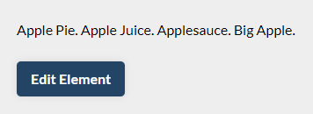
↓
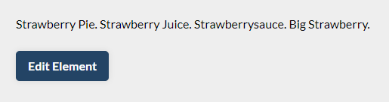

Collect List Items
Write a JS function that scans a given HTML list and appends all collected list items’ text to a textarea on the same page when the user clicks on a button.

Input / Output
There will be no input / output, your program should instead modify the DOM of the given HTML document.

Examples
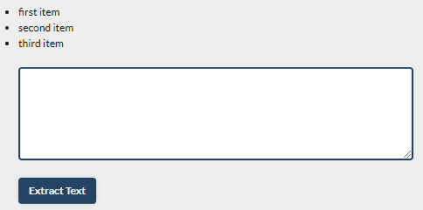
↓
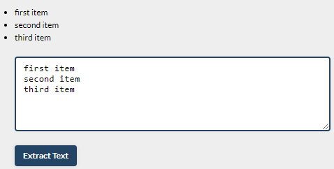
- Sum Numbers
Write a JS function that reads two numbers from input fields in a web page and puts their sum in another field when the user clicks on a button.

Input / Output
There will be no input / output, your program should instead modify the DOM of the given HTML document.

Examples
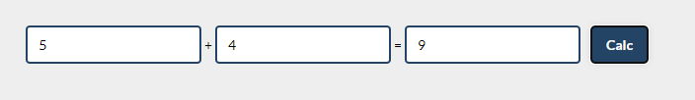

Show More
Write a JS function that expands a hidden section of text when a link is clicked. The link should disappear as the rest of the text shows up.

Input / Output
There will be no input / output, your program should instead modify the DOM of the given HTML document.

Examples

↓


Colorize Table
Write a JS function that changes the color of all even rows when the user clicks a button. Apply the color "Teal" to the target rows.

Input / Output
There will be no input / output, your program should instead modify the DOM of the given HTML document.

Examples
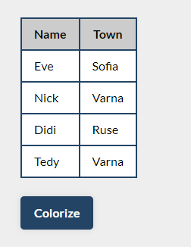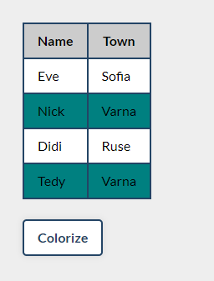

Sum Table
Write a JS function that finds the first table in a document and sums the values in the last column. The result is then displayed in an element with ID "sum".

Input / Output
There will be no input / output, your program should instead modify the DOM of the given HTML document.

Examples
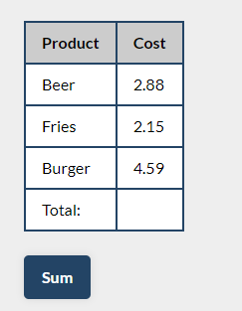 → 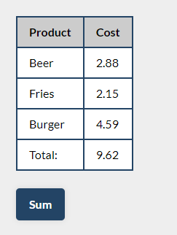

Extract Parenthesis
Write a JS function that when executed, extracts all parenthesized text from a target paragraph by given element ID. The result is a string, joined by "; " (semicolon, space).

Input
Your function will receive a string parameter, representing the target element ID, from which text must be extracted. The text should be extracted from the DOM.

Output
Return a string with all matched text, separated by "; " (semicolon, space).

Examples
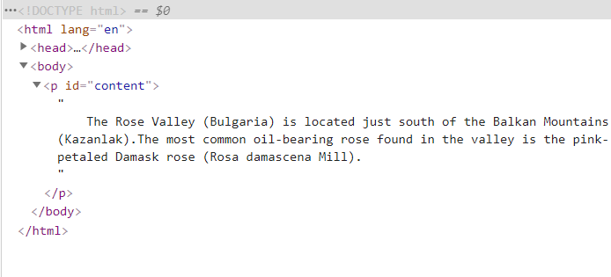
Sample call
let text = extract("content");
Result (stored in variable text)
Bulgaria; Kazanlak; Rosa demascena Mill

