Exercise: DOM Events
Submit your solutions in the SoftUni judge system at https://judge.softuni.org/Contests/4368/DOM-Manipulation-and-Events-Exercise
Environment Specifics
Please, be aware that every JS environment may behave differently when executing code. Certain things that work in the browser are not supported in Node.js, which is the environment used by Judge.
The following actions are NOT supported:
- .forEach() with NodeList (returned by querySelector() and querySelectorAll())
- .forEach() with HTMLCollection (returned by getElementsByClassName() and element.children)
- Using the spread-operator (...) to convert a NodeList into an array
- append() in Judge (use only appendChild())
- prepend()
- replaceWith()
- replaceAll()
- closest()
- replaceChildren()
- Always turn the collection into a JS array (forEach, forOf, et.)
If you want to perform these operations, you may use Array.from() to first convert the collection into an array.

Sections
You will receive an array of strings. For each string, create a div with a paragraph with the string in it. You should append all divs to the element with an id "content".

Example
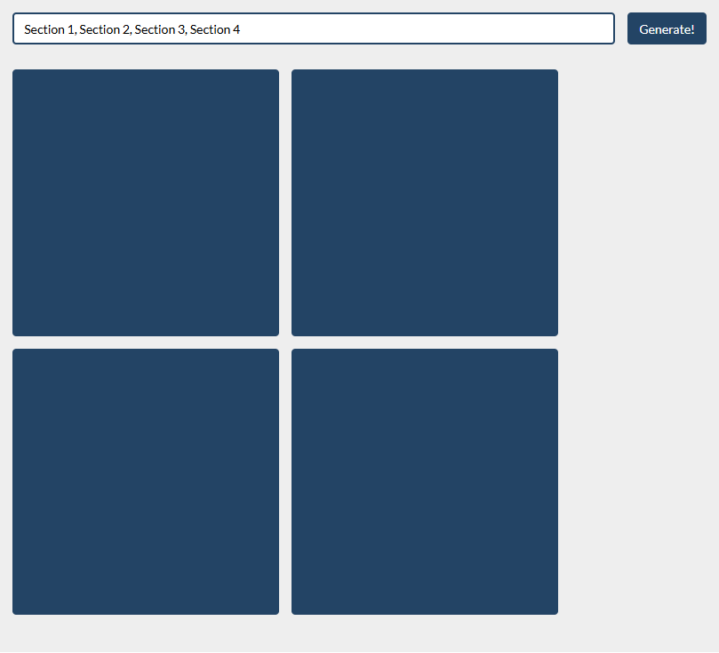

Time Converter
Create a program that converts different time units. Your task is to add a click event listener to all [CONVERT] buttons. When a button is clicked, read the corresponding input field, convert the value to the three other time units and display it in the input fields.

Example
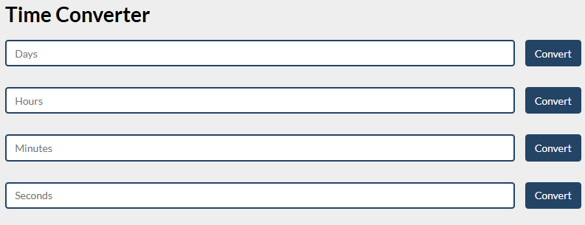
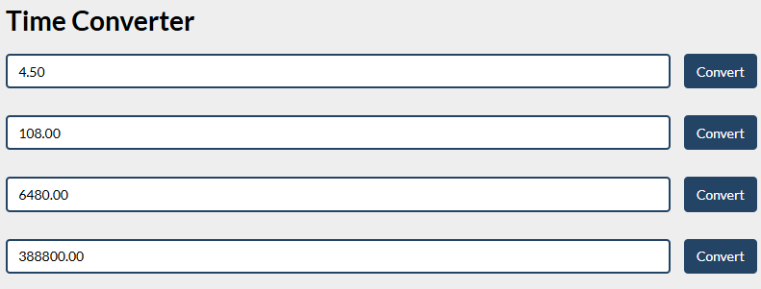
One day is equal to 24 hours/1440 minutes/86400 seconds. Whichever button we click, the input fields should change depending on the added value on the left. (For example, if we write 48 hours and click convert the days, the field value should change to 2).

Locked Profile
In this problem, you should create a JS functionality that shows and hides the additional information about users.
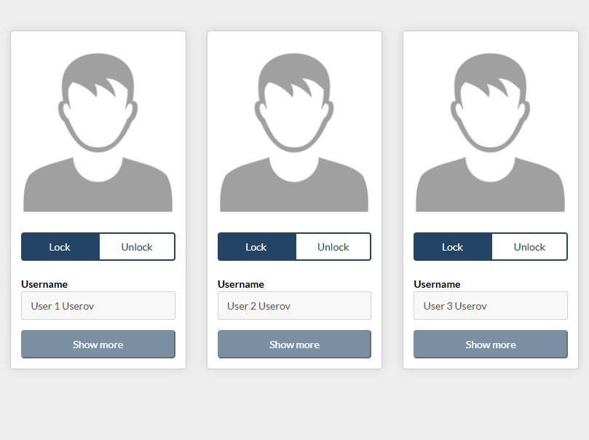
When one of the [Show more] buttons is clicked, the hidden information inside the div should
be shown, only if the profile is not locked! If the current profile is locked, nothing should happen.
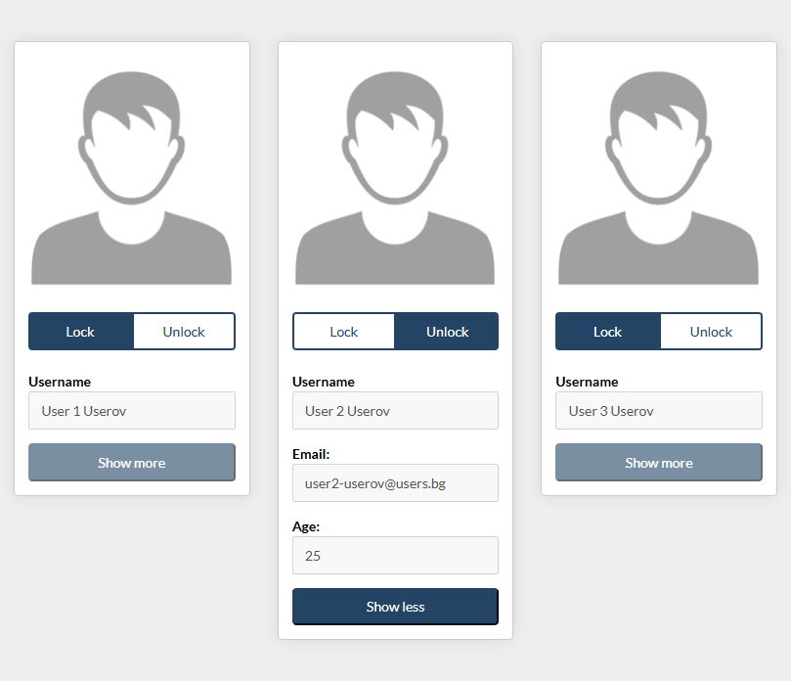
If the hidden information is displayed and we lock the profile again, the [Hide it] button should not be working!
Otherwise, when the profile is unlocked and we click on the [Hide it] button, the new fields must hide again.

Fill Dropdown
Your task is to take values from input fields with ids "newItemText" and "newItemValue". Then you should create and append an <option> to the <select> with id "menu".

Example
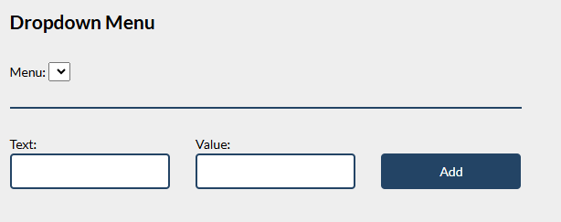

Hints
- Your function should take the values of newItemText and newItemValue. After that, you should create a new option element and set its textContent and its value to the newly taken ones.
- Once you have done all of that, you should append the newly created option as a child to the select item with id "menu".
- Finally, you should clear the value of the two input fields.

Encode and Decode Messages
In this problem, you should create a JS functionality that encodes and decodes some messages which travel to
the network.
This program should contain two functionalities.
The first one is to encode the given message and send it to the receiver.
The second one is to decode the received message and read it (display it).
When the [Encode and send it] button is clicked, you should get the given message from the first textarea. When you get the current message, you should encode it as follows:
- Change the ASCII CODE on every single character in that message when you add 1 to the current ASCII NUMBER, that represents the current character in that message
- Clear the sender textarea and add the encoded message to the receiver textarea
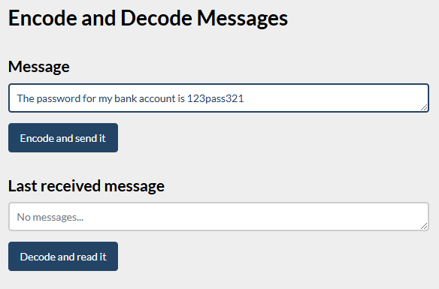
After clicking the [Encode and send it] button the result should be:
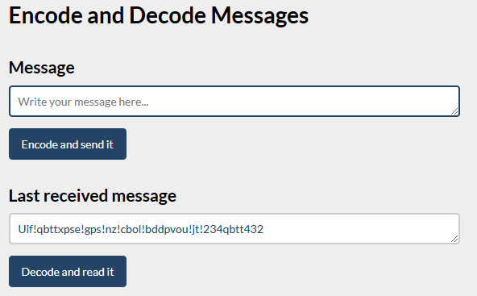
After that, when the [Decode and read it] button is clicked. You need to get the encoded message from the receiver textarea and do the opposite logic from encoding:
- Subtract 1 from the current ASCII NUMBER, that represents the current character in that message
- Replace the encoded message with the already decoded message in the receiver textarea, to make it readable
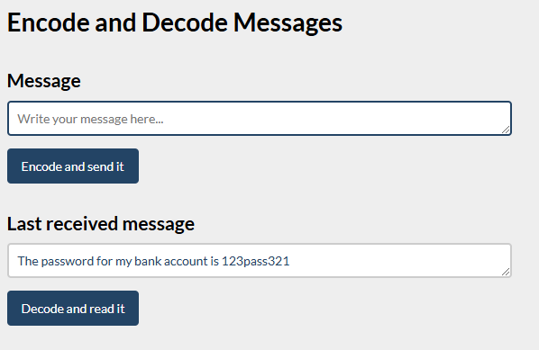

Furniture
You will be given some furniture as an array of objects. Each object will have a name, a price, and a decoration factor.
When the ["Generate"] button is clicked, add a new row to the table for each piece of furniture with image, name, price, and decoration factor (code example below).
When the ["Buy"] button is clicked, get all checkboxes that are marked and show in the result textbox the names of the piece of furniture that were checked, separated by a comma and single space (", ") in the following format: "Bought furniture: {furniture1}, {furniture2}…".
On the next line, print the total price in the format: "Total price: {totalPrice}". Finally, print the average decoration factor in the format: "Average decoration factor: {decFactor}"

Input Example
[{"name": "Sofa", "img": "https://res.cloudinary.com/maisonsdumonde/image/upload/q_auto,f_auto/w_200/img/grey-3-seater-sofa-bed-200-13-0-175521_9.jpg", "price": 150, "decFactor": 1.2}]

Examples
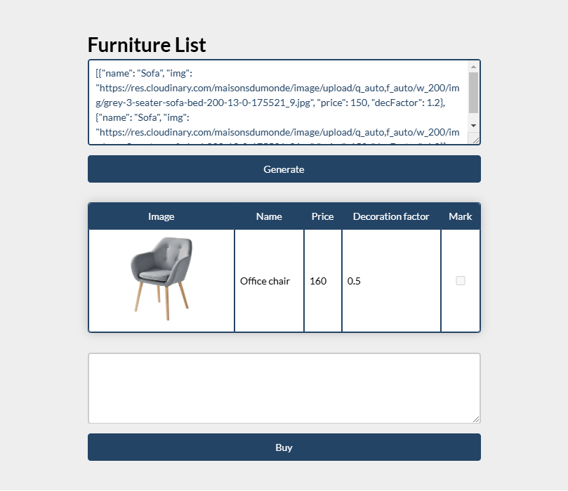

Distance Converter *
Your task is to convert from one distance unit to another by adding a click event listener to a button. When it is clicked, read the value from the input field and get the selected option from the input and output units dropdowns. Then calculate and display the converted value in the disabled output field.

Example
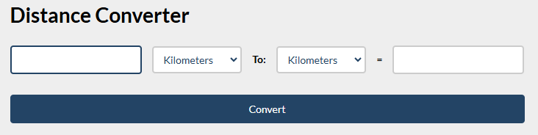

Hints
- Multiply the incoming distance by the following conversion rates to convert to meter
- Divide to convert from meters to the required output unit
- To see which option is selected, read the properties of its parent: value gives you the value of the selected option (as displayed in the HTML), selectedIndex gives you the 0-based index of the selected option. For example, if miles are selected, inputUnits.value is "mi", inputUnits.selectedIndex is 4. Option text is irrelevant
- Use the following table information to do that:
1 km | 1000 m
1 m | 1 m
1 cm | 0.01 m
1 mm | 0.001 m
1 mi | 1609.34 m
1 yrd | 0.9144 m
1 ft | 0.3048 m
1 in | 0.0254 m

Sudomu *
Write a function that implements SUDOMU (Sudoku inside the DOM).
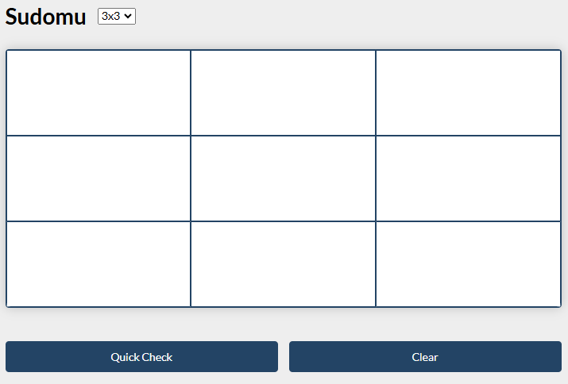
The rules are simple and they are the same as the typical sudoku game (for more information, click here).
If the table is filled with the right numbers, and the ["Quick Check"] button is clicked, the expected result should
be:
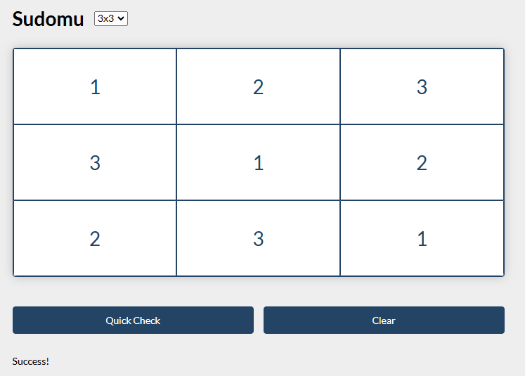
The table borer should be changed to: "2px solid green". The text content of the paragraph
inside the div with an id "check" must be "Success!"
Otherwise, when the filled table does not solve the sudomu, the result should be:
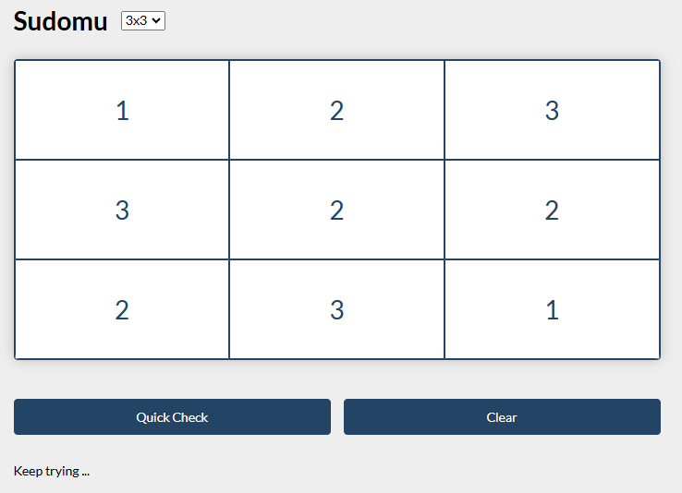
The table border should be changed to: "2px solid red". The text content of the paragraph inside the div
with an id "check" must be: "Keep trying..."
The ["Clear"] button clears the whole SUDOMU (removes all numbers) and the paragraph
which contains the messages.

JavaScript Quizz *
Write a function that has the functionality of a quiz.
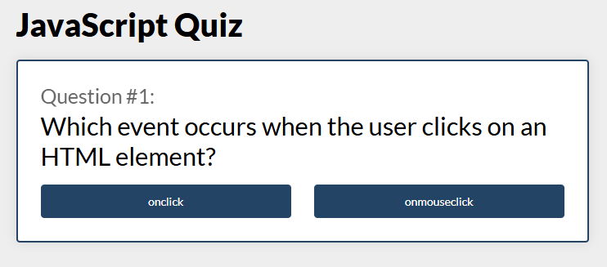
Three sections contain one question and 2 possible answers.
The right answer is only one!
When one of the list elements is clicked, the next section must appear (if any…).
After all three questions have been answered, the results ul must appear, (Use 'none' and 'block' to hide and show the question sections), and the results must be added in the h1.
If all questions are answered correctly, you should print the following message:
"You are recognized as top JavaScript fan!"
Otherwise, just print "You have {rightAnswers} right answers". If the right answers is only one, print: "You have {rightAnswers} right answer".
The right answers are:
- onclick
- JSON.stringify()
- A programming API for HTML and XML documents


