Problem 2 – Snakes
A snake is a sequence of several square blocks, attached one after another. A snake starts with a block at some position and continues with another block to the left, right, up or down, then again with another block to the left, right, up or down, etc. A snake of size N consists of a sequence of N blocks and is not allowed to cross itself.
You are given a number N and you should find all possible snakes of N blocks, represented as sequences of moves denoted as: S (start), L (move left), R (move right), U (move up) and D (move down). Examples (for N = 1, 2, 3, 4, and 5):
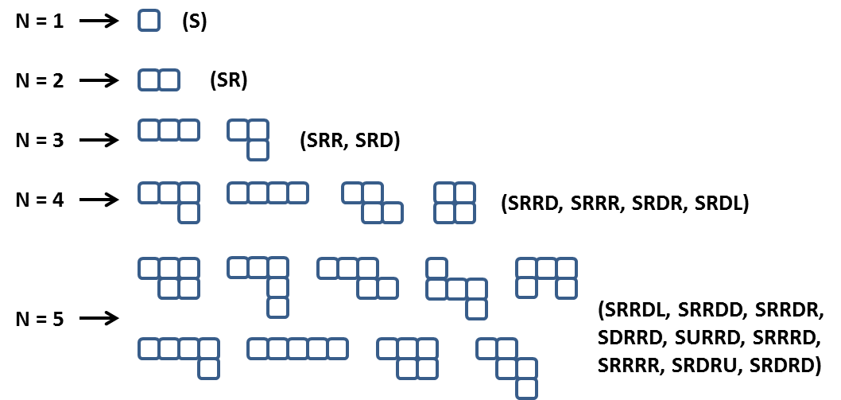
Note: some figures could look visually the same but represent different snakes, e.g. SRRDL and SRDRU.
Some snakes (sequences of blocks) are the same and should be printed only once. If after a number of rotations and/or flips two snakes are equal they are considered the same and should be printed only once. For example the snakes SRRD, SRRU, SLLD, SLLU, SRUU and SUUR are the same:

Not all forms consisting of N blocks are snakes of size N. Examples of non-snake forms:


Note: When generating the snakes, there may be different correct answers. When testing your solution, priority should be as follows: R -> D -> L -> U. The visual example above for n = 5 does NOT follow this priority.

Input
- The input should be read from the console.
- It will contain an integer number N in the range [1 ... 15].
- The input data will always be valid and in the format described. There is no need to check it explicitly.

Output
- The output should be printed on the console. It should consist of a variable number of lines:
- Each line should hold a snake represented as a sequence of moves.
- On the last line, print the number of snakes in format: "Snakes count = {0}".

Constraints
- Allowed working time for your program: 10 seconds. Allowed memory: 512 MB.

Examples
Input | Sample Output | Comments
2 | SR  Snakes count = 1 | Note that SU, SL and SD are also correct outputs. However, SR takes precedence because R has priority over all other directions.
4 | SRRR  SRRD  SRDR  SRDL  Snakes count = 4 | Note that there are many other correct outputs for N = 4, but this is the expected output according to the priority of directions (right, down, left, up).

