More Exercises: Advanced Arrays
Submit your solutions in the SoftUni judge system at: https://judge.softuni.org/Contests/1301/Arrays-Advanced-More-Exercises

Equal Neighbors
Write a function that finds the number of equal neighbor pairs inside a matrix of variable size and type (numbers or strings).
The input comes as an array of arrays, containing string elements (2D matrix of strings).
The output is the return value of your function. Save the number of equal pairs, you find and return it.

Examples
Input | Output |  | Input | Output
[['2', '3', '4', '7', '0'],  ['4', '0', '5', '3', '4'],  ['2', '3', '5', '4', '2'],  ['9', '8', '7', '5', '4']] | 1 |  | [['test', 'yo', 'yo', 'ho'],  ['well', 'done', 'no', '6'],  ['not', 'done', 'yet', '5']] | 2

Bunny Kill
In the underground world of bunnies, mafia and corruption have taken over. Snowball is on a mission to infiltrate a certain deserted military hanger, supposedly filled with convict bunnies.
You will be given a matrix of integers, each integer separated by a single space, and each row on a new line, which will represent the current situation in the hangar. Then on the last line of input, you will receive indexes - coordinates to several cells in the hangar separated by a single space, in the following format: row1,column1 row2,column2 row3,column3…
On those cells, there are bunnies with bombs. Snowball is smart and knows that bombs are an easy way to neutralize enemies, especially when they are the enemy’s bombs.
Snowball will proceed to eliminate every bunny with a bomb, one by one in the order they were given. When a bunny with a bomb is killed, it explodes and deals damage equal to its integer value, to all the cells around it (in every direction and all diagonals). If a bomb bunny is caught in the explosion and killed, that bomb is no longer valid and will not explode. When a bunny is damaged, it reduces its integer value by the damage value. When a bunny’s value reaches 0, it dies. When a bunny explodes, it dies.
When Snowball is done with all the bomb bunnies, he will proceed to kill any other convict bunny, which has remained alive. You must count all the damage Snowball did in the hangar. Note that bomb explosion damage does not count as Snowballs damage, but the killing of bomb bunnies and other bunnies DOES. Snowball’s damage for every bunny is equal to the bunny at that cell’s integer value.

Input
- The input data is passed to the first function found in your code as an array of strings.
- Each entry in the array represents a row of the matrix, in the form of integers separated by a space.
- On the last line, you will receive the coordinates of the cells with the bomb bunnies.

Output
- On the first line, you need to print Snowball’s damage.
- On the second line, you need to print the number of bunnies, who HE killed.

Constraints
- The size of the matrix will be between [0…1000].
- The coordinates to the bomb bunnies will always be in the matrix.
- The integers of the matrix will be in the range [0…10000].
- Allowed time/memory: 250ms/16MB

Examples
Input | Output | Comments
['10 10 10',  '10 10 10',  '10 10 10',  '0,0'] | 60  6 | The blue number represents a bunny which is a bomb. The red numbers are bunnies that have been hit by the exploding bunny. Since the exploding bunny has a value of 10, all the damaged bunnies suffer 10 damage. Since their values are also 10, the explosion kills them and they are no longer valid targets for Snowball. So in total Snowball deals 60 dmg (the 5 untargeted bunnies + the exploding one) and kills 6 units.
Input | Output | Comments
['5 10 15 20',  '10 10 10 10',  '10 15 10 10',  '10 10 10 10',  '2,2 0,1'] | 70  7 | Here the purple bunnies are caught in the explosion, but since their values are bigger than the exploding bunny’s value – they don’t die and are left for Snowball to kill.  The damage Snowball deals here is 10 + 10 + 5 + 20 + 10 + 5 + 10 = 70. The values for the bunnies who survived the explosion are 5 because the explosion reduced their initial values  15 (initial) – 10 (exploding bunny) = 5

Air Pollution
Write a program that tracks the pollution in the air Sofia. You will receive two arguments – the first is the map of Sofia represented by a matrix of numbers and the second is an array of strings representing the forces affecting the air quality. The map will always be with 5 rows and 5 columns in a total of 25 elements - blocks. Each block’s particle pollution (PM) is affected by 3 forces received in the following formats:
- "breeze {index}" – index is the row where all column’s value drops by 15 PM
- "gale {index}" – index is the column in all rows where value drops by 20 PM
- "smog {value}" – all blocks in the map increase equally by the given value’s PM
The threshold in each block is 50 PM. If it is below that number, the block’s air is considered normal but if it reaches or goes over it, that block’s air is considered polluted. Also, note that the polluted particles in a block cannot go below zero.
Finally, your program needs to find if there are any polluted blocks and print them in the format given below.

Input
You will receive two arguments:
- The first argument is an array with five strings – rows of the matrix with columns separated by space that must be parsed as numbers, representing the map of Sofia.
- The second argument is an array of strings – each string consists of one of the words (breeze/gale/smog) and a number separated by space, representing the different forces.

Output
Print on the console a single line:
- If there are polluted blocks in the map, use their coordinates in the following format:
- "[{rowIndex}-{columnIndex}]"
Note that you must start from the top left corner of the map moving to the bottom right corner horizontally. Then separate each formatted block’s coordinates with comma and space and print them in a single line in the following format:
- "Polluted areas: {block1}, {block2}, {block3}, …"
- If there are no polluted blocks in the map print:
- "No polluted areas"

Constraints
- The number of rows and columns for the matrix will always be 5
- The number in each block will be an integer in the range [0..1000] inclusive
- The number of elements in the second input argument will be in the range [0..100] inclusive
- Given smog’s value will be an integer in the range [0..100] inclusive
- Given indexes will always be valid

Examples
Input | Output
['5 7 72 14 4',  '41 35 37 27 33',  '23 16 27 42 12',  '2 20 28 39 14',  '16 34 31 10 24'],  ['breeze 1', 'gale 2', 'smog 25'] | Polluted areas: [0-2], [1-0], [2-3], [3-3], [4-1]

Explanation
Graphic diagram explaining the first example’s program flow:
input
breeze 1 (-15)
gale 2 (-20)
smog 25 (+25)
polluted areas

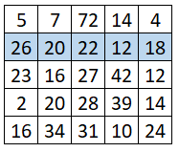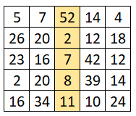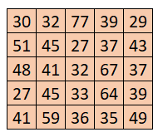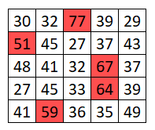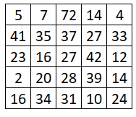

Input | Output
['5 7 3 28 32',  '41 12 49 30 33',  '3 16 20 42 12',  '2 20 10 39 14',  '7 34 4 27 24'],  ['smog 11', 'gale 3', 'breeze 1', 'smog 2'] | No polluted areas
['5 7 2 14 4',  '21 14 2 5 3',  '3 16 7 42 12',  '2 20 8 39 14',  '7 34 1 10 24'],  ['breeze 1', 'gale 2', 'smog 35'] | Polluted areas: [2-1], [2-3], [3-1], [3-3], [4-1], [4-4]

Jan's Notation
Write a program that parses a series of instructions written in postfix notation and executes them (postfix means the operator is written after the operands). You will receive a series of instructions – if the instruction is a number, save it; otherwise, the instruction is an arithmetic operator (+-*/) and you must apply it to the most two most recently saved numbers. Discard these two numbers and in their place, save the result of the operation – this number is now eligible to be an operand in a subsequent operation. Keep going until all input instructions have been exhausted, or you encounter an error.
In the end, if you’re left with a single saved number, this is the result of the calculation and you must print it. If there are more numbers saved, then the user-supplied too many instructions and you must print "Error: too many operands!". If at any point during the calculation you don’t have two numbers saved, the user-supplied too few instructions and you must print "Error: not enough operands!". See the examples for more details.

Input
You will receive an array with numbers and strings – the numbers will be operands and must be saved; the strings will be arithmetic operators that must be applied to the operands.

Output
Print on the console on a single line the final result of the calculation or an error message, as instructed above.

Constraints
- The numbers (operands) will be integers
- The strings (operators) will always be one of +-*/
- The result of each operation will be in the range [-2⁵³…2⁵³-1] (MAX_SAFE_INTEGER will never be exceeded)

Examples
Input | Output | Explanation
[3,  4,  '+'] | 7 | The first instruction is a number, therefore we save it. The next one is also a number, we save it too.  The third instruction is a string, so it must be an operator – we remove the last two numbers we saved, and operate: 3+4=7. The result of this operation is then saved where the two operands used to be.  We’ve run out of instructions, so we check the saved values – we only have one, so this must be the final result. We print it on the console.
[5,  3,  4,  '*',  '-'] | -7 | We save in order 5, 3, and 4. The result of the operation 3*4 is 12, which we save in place of 3 and 4.  Currently, we have 5 and 12 saved. The result of the operation 5-12 is -7, which we save in place of 5 and 12.  We have no more instructions and only one value saved, which we print.

Input | Output |  | Input | Output
[7,  33,  8,  '-'] | Error: too many operands! |  | [15,  '/'] | Error: not enough operands!

Input | Output | Explanation |  | Input | Output | Explanation
[31,  2,  '+',  11,  '/'] | 3 | (31+2)/11 |  | [-1,  1,  '+',  101,  '*',  18,  '+',  3,  '/'] | 6 | (-1+1)*101+18/3

Kate's Way Out
Kate is stuck in a maze. You should help her to find her way out.
On the first line, you will be given how many rows there are in the maze. On the following n lines, you will be given the maze itself. Here is a legend for the maze:
- "#" - means a wall; Kate cannot go through there
- " " - means empty space; Kate can go through there
- "k" - the initial position of Kate; start looking for a way out from there
There are two options: Kate either gets out or not:
- If Kate can get out, print the following:
"Kate got out in {number_of_moves} moves".
Note: If there are two or more ways out, she always chooses the longest one.
- Otherwise, print: "Kate cannot get out".

Examples
Input | Output
[  4,  "######",  "## k#",  "## ###",  "## ###"  ] | Kate got out in 5 moves
[  5,  "######",  "## k#",  "## ###",  "######",  "## ###"  ] | Kate cannot get out

Rosetta Stone
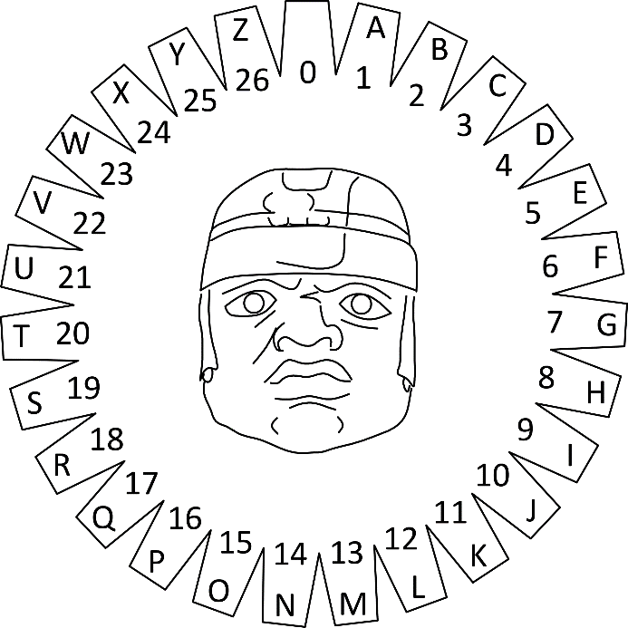
You will be given an encoded message and a template matrix for decoding it. The decoding is done by overlaying the template on top of the stone with the message and performing an arithmetic operation with the numbers that overlap. Each pair of numbers (one from the message and one from the template matrix) is added together and the resulting number is located on the wheel of letters (pictured to the You may count more than one full revolution around the wheel (e.g. 6 is the same as 33 and so on). Repeat this process for all symbols of the message.
If the decoding template matrix is smaller than the message, shift the template horizontally by as many cells as it is wide, so it covers the next section of the message (see example). Once you reach the last column of the message matrix, if there are more rows left, shift the template back to the first column, but offset it vertically by as many cells as it is high. See the example’s explanation for more information.

Input
You will receive an array of strings. The first element represents a number n, which is the length of the template matrix for decoding. The next n elements represent rows in the decoding template matrix, with columns separated by space. The rest of the elements are all rows of the encoded message matrix, with columns in each row separated by space.

Output
Print the decoded message in uppercase on a single line on the console. The final message is joined from all resulting cells, starting from top left, going right, row by row. Trailing spaces are ignored.

Examples
Input | Output
[ '2',  '59 36',  '82 52',  '4 18 25 19 8',  '4 2 8 2 18',  '23 14 22 0 22',  '2 17 13 19 20',  '0 9 0 22 22' ] | I CAME I SAW I CONQUERED

Explanation
The line highlighted in red in the input is the number of lines of the decoding template matrix. The lines highlighted in blue are the decoding template itself. The remaining lines are the encoded message matrix. When we overlay the template over the message, 59 and 36 from the first line are on top of 4 and 18, 82 and 52 are on top of 4 and 2.
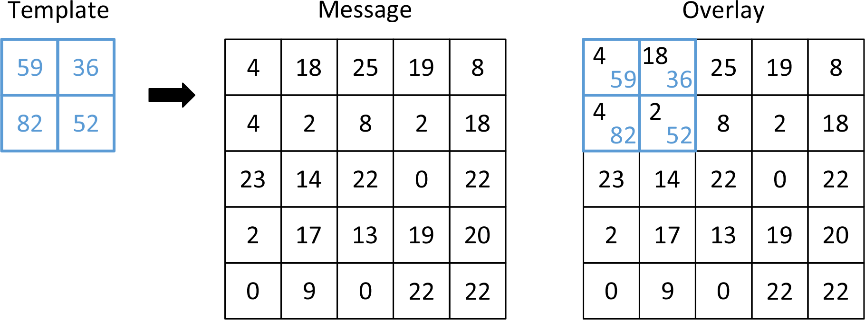
We add each pair to get 63 and 54 on the first line and 86 and 54 on the second. Looking up these numbers on the wheel of letters yields the following:  - For 63 we count two full revolutions and then we count 9 more, which corresponds to the letter ‘I’  - For 54 we count exactly two full revolutions, ending at 0, which is empty space  - For 86 we count 3 full revolutions and 5 more, ending at ‘E’  - For 54 we get empty space again |  | 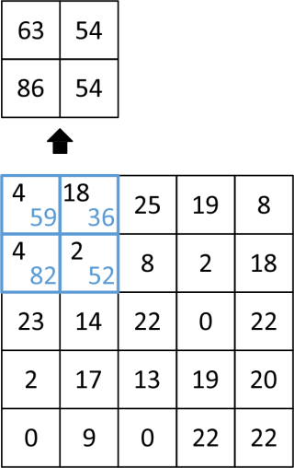
We’ve run out of slots on the template, so we shift it 2 indexes to the right (the width of the template is 2), to decode the next segment of the message. This time we overlay it on top of 25, 19, 8, and 2, and after adding the numbers, we get 84, 55, 90, and 54. They correspond to ‘C’, ‘A’, ‘I’ and empty space, respectively. |  | 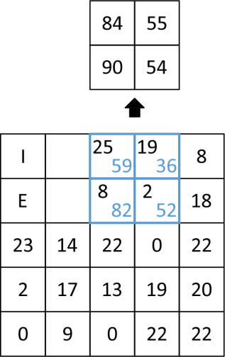
We keep repeating this for the entire message. Once we reach the end of the row, we shift the template down by its height (2 cells) and back to the beginning of the message. Any slots of the template that overhang at the end of the row are ignored. | 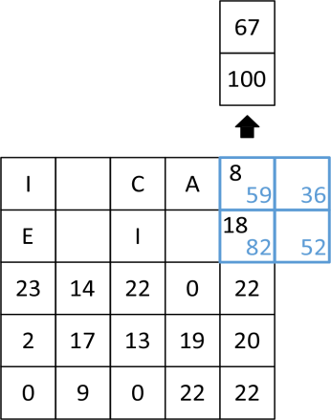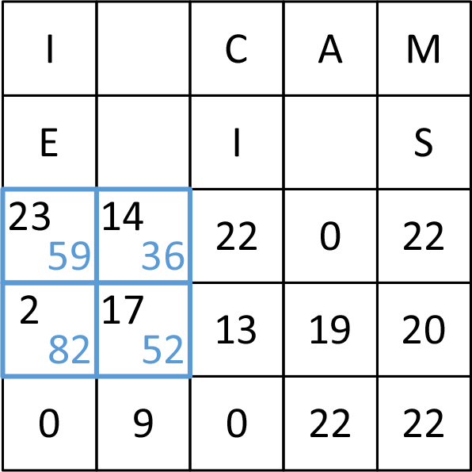
The process is repeated for all remaining cells of the message. Note any parts of the template matrix that overhang below are ignored.
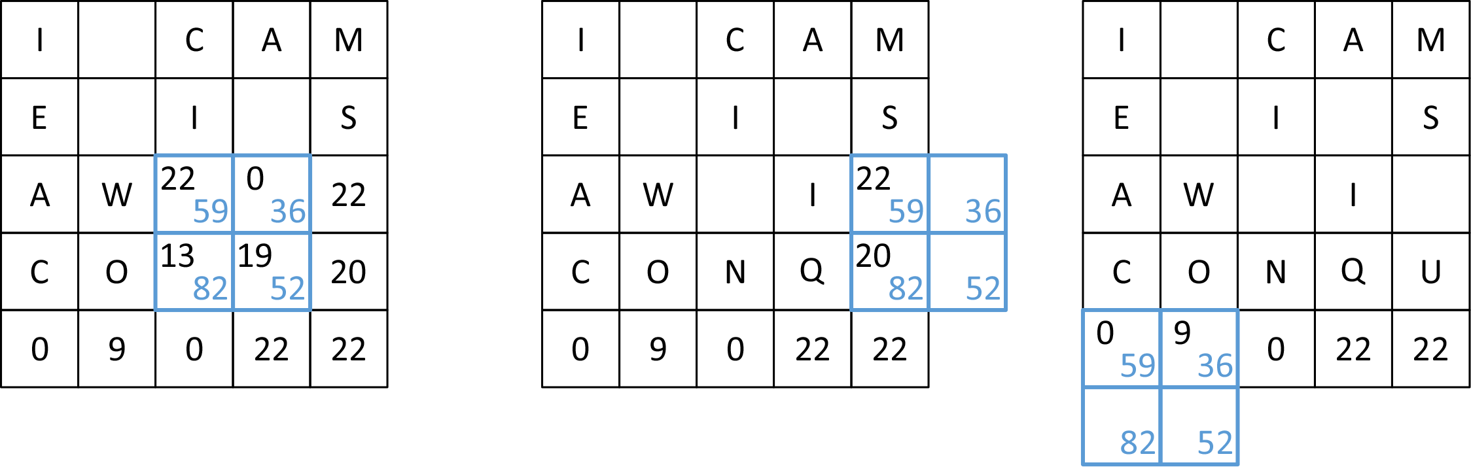
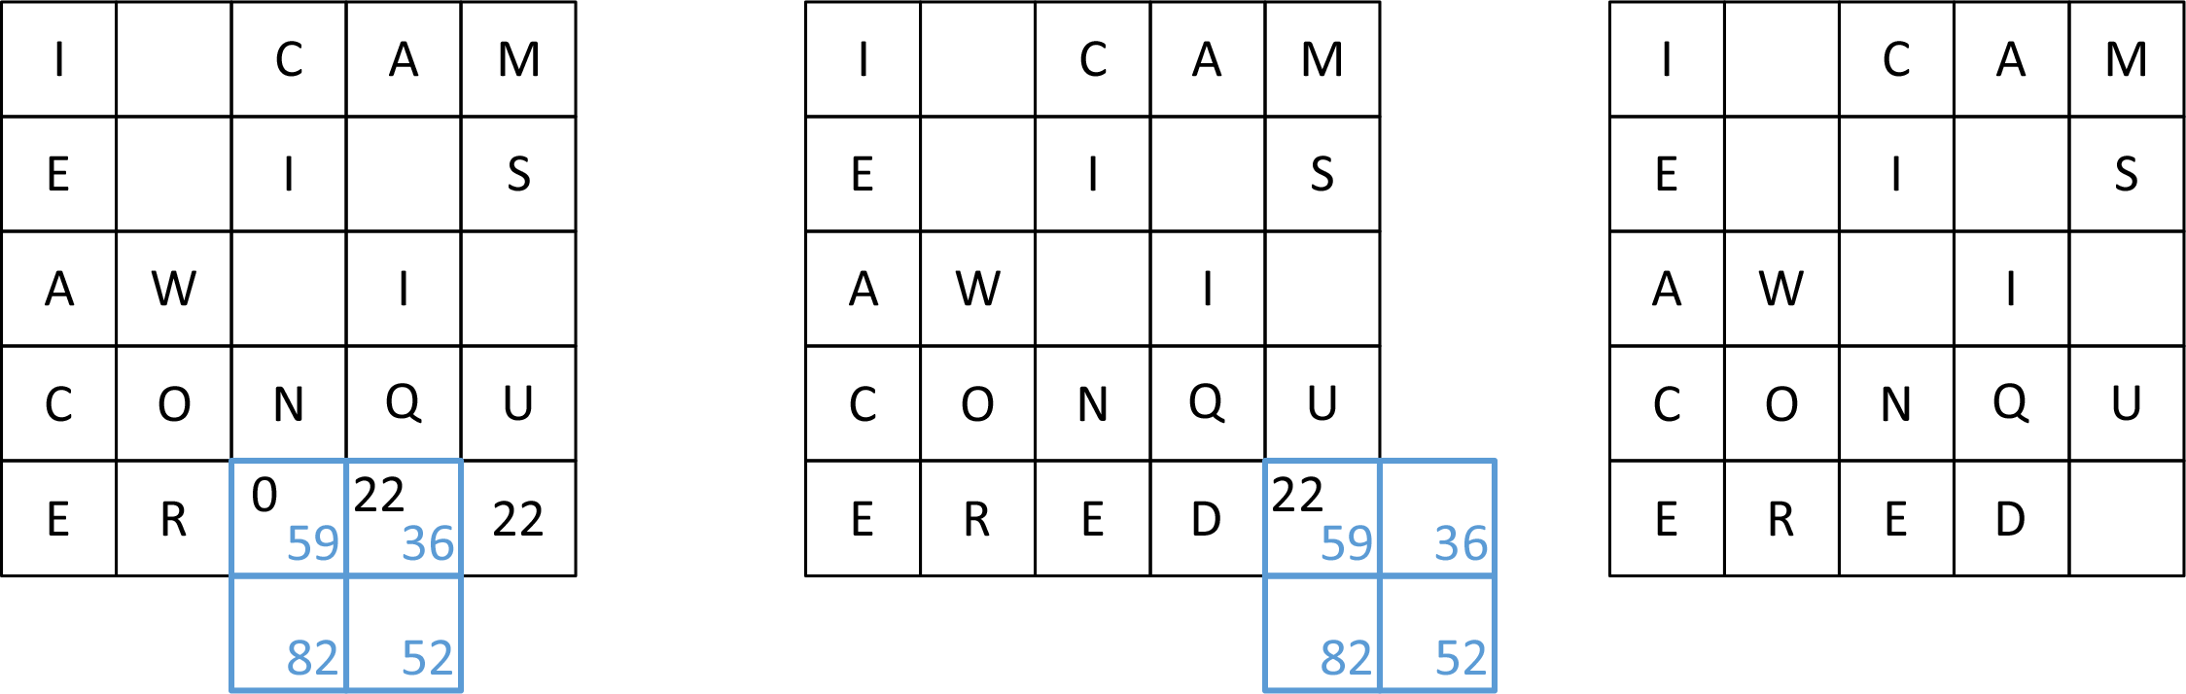

Input | Output
[ '2',  '31 32',  '74 37',  '19 0 23 25',  '22 3 12 17',  '5 9 23 11',  '12 18 10 22' ] | WE COME IN PEACE

