Lab: Regular Expressions
Submit your solutions in the SoftUni judge system at: https://judge.softuni.org/Contests/1708/Regular-Expressions-Lab

Match Full Name
Write a JavaScript function to match full names from a list of names and print them on the console.

Writing the Regular Expression
First, write a regular expression to match a valid full name, according to these conditions:
- A valid full name has the following characteristics:
  - It consists of two words.
  - Each word starts with a capital letter.
  - After the first letter, it only contains lowercase letters afterward.
  - Each of the two words should be at least two letters long.
  - The two words are separated by a single space.
To help you out, we've outlined several steps:
- Use an online regex tester like https://regex101.com/
- Check out how to use character sets (denoted with square brackets - "[]")
- Specify that you want two words with a space between them (the space character ' ', and not any whitespace symbol)
- For each word, specify that it should begin with an uppercase letter using a character set. The desired characters are in a range – from 'A' to 'Z'.
- For each word, specify that what follows the first letter are only lowercase letters, one or more – use another character set and the correct quantifier.
- To prevent capturing of letters across new lines, put "\b" at the beginning and the end of your regex. This will ensure that what precedes and what follows the match is a word boundary (like a new line).
To check your RegEx, use these values for reference (paste all of them in the Test String field):
Match ALL of these | Match NONE of these
Ivan Ivanov | ivan ivanov, Ivan ivanov, ivan Ivanov, IVan Ivanov, Ivan IvAnov, Ivan Ivanov
By the end, the matches should look something like this:
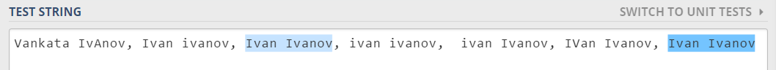
After you've constructed your regular expression, it's time to write the solution in JavaScript.

Implementing the Solution in JavaScript
Create a new JavaScript file and copy your regular expression into a variable:
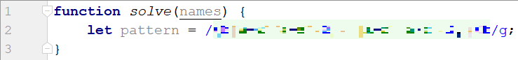
Note: You should put "/" before and after the pattern so that it is interpreted as a RegEx pattern. Also, place the 'g' (global) flag after it, so that you get all the matches in the text.
Now, it's time to read the input, extract the matches from it and push them into an array. For this we can use exec():
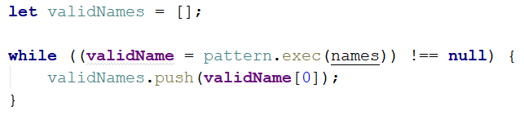
The exec method matches the string and the pattern keeps the first index after the match. This way the next time exec runs it starts looking after the last match. If there are no more matches, it will return null.
We are declaring a variable in the while loop's condition because we need to check every time if there are any more matches.
Now we have an array (validNames), which holds all of the valid names in the input. All that is left is to join it by space and print it (do this by using join()):

Examples
Input
"Ivan Ivanov, Ivan ivanov, ivan Ivanov, IVan Ivanov, Test Testov, Ivan Ivanov"
Output
Ivan Ivanov Test Testov

Match Phone Number
Write a regular expression to match a valid phone number from Sofia. After you find all valid phones, print them on the console, separated by a comma and a space ", ".

Compose the Regular Expression
A valid number has the following characteristics:
- It starts with "+359"
- Then, it is followed by the area code (always 2)
- After that, it's followed by the number itself:
  - The number consists of 7 digits (separated into two groups of 3 and 4 digits respectively).
- The different parts are separated by either a space or a hyphen ('-').
You can use the following RegEx properties to help with the matching:
- Use quantifiers to match a specific number of digits
- Use a capturing group to make sure the delimiter is only one of the allowed characters (space or hyphen) and not a combination of both (e.g. +359 2-111 111 has mixed delimiters, it is invalid). Use a group backreference to achieve this.
- Add a word boundary at the end of the match to avoid partial matches (the last example on the right-hand side).
- Ensure that before the '+' sign there is either a space or the beginning of the string.
You can use the following table of values to test your RegEx against:
Match ALL of these | Match NONE of these
+359 2 222 2222  +359-2-222-2222 | 359-2-222-2222, +359/2/222/2222, +359-2 222 2222  +359 2-222-2222, +359-2-222-222, +359-2-222-22222

Implement the Solution in JavaScript
Now it's time to write the solution, so let's start writing!
First, just like in the previous problem, put your RegEx in a variable:
After that, let's make an array of matches using like in the previous exercise:
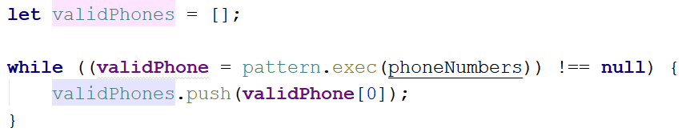
Now let's print all the matches, separated by ", ":
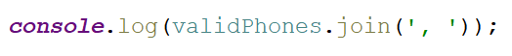

Examples
Input
['+359 2 222 2222,359-2-222-2222, +359/2/222/2222, +359-2 222 2222 +359 2-222-2222, +359-2-222-222, +359-2-222-22222 +359-2-222-2222']
Output
+359 2 222 2222, +359-2-222-2222
Input
['+359 2 357 3351 +359 2 22 2222 +359 2 173 3408 +359-2-789-2584 +359 2 193 3953 +359-2-961-0248 +359-2-789-2584 +359 2 222 222 +360 2 222 2222 +359 2 727 9740 +359-2-854-2280 +359 2 193 3953 +359 2 357 3351 +359 2 558 8560 +359 2 222 222']
Output
+359 2 357 3351, +359 2 173 3408, +359-2-789-2584, +359 2 193 3953, +359-2-961-0248, +359-2-789-2584, +359 2 727 9740, +359-2-854-2280, +359 2 193 3953, +359 2 357 3351, +359 2 558 8560

Match Dates
Write a program, which matches a date in the format "dd{separator}MMM{separator}yyyy".

Compose the Regular Expression
Every valid date has the following characteristics:
- Always starts with two digits, followed by a separator
- After that, it has one uppercase and two lowercase letters (e.g. Jan, Mar).
- After that, it has a separator and exactly 4 digits (for the year).
- The separator could be either of three things: a period ("."), a hyphen ("-") or a forward-slash ("/")
- The separator needs to be the same for the whole date (e.g. 13.03.2016 is valid, 13.03/2016 is NOT). Use a group backreference to check for this.
You can follow the table below to help with composing your RegEx:
Match ALL of these | Match NONE of these
13/Jul/1928, 10-Nov-1934, 25.Dec.1937 | 01/Jan-1951, 23/sept/1973, 1/Feb/2016
Use named capturing groups for the day, month and year.
Since this problem requires more complex RegEx, which includes named capturing groups, we'll take a look at how to construct it:
- First off, we don't want anything at the start of our date, so we're going to use a word boundary "\b":
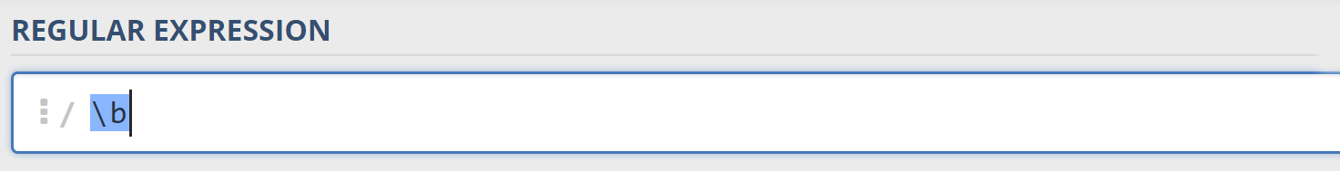
- Next, we're going to match the day, by telling our RegEx to match exactly two digits, and since we want to extract the day from the match later, we’re going to put it in a capturing group:
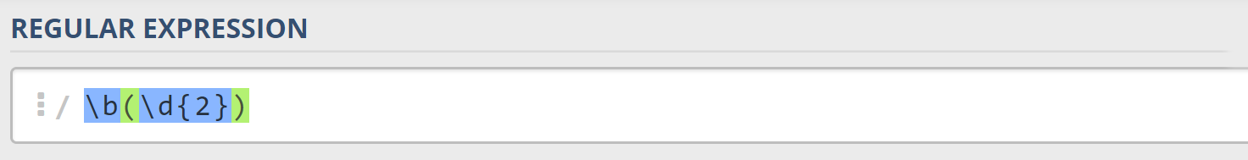
We're also going to give our group a name since it’s easier to navigate by group name than by group index:
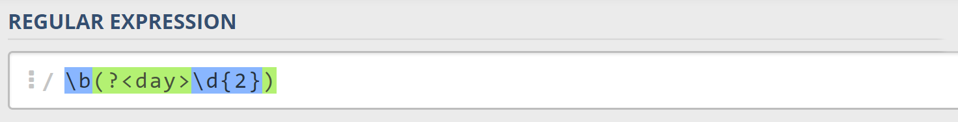
- Next comes the separator – either a hyphen, period, or forward slash. We can use a character class for this:
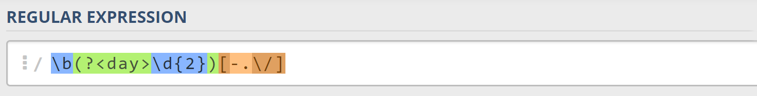
Since we want to use the separator we matched here to match the same separator further into the date, we're going to put it in a capturing group:
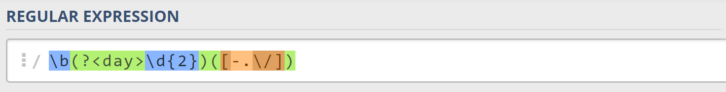
- Next comes the month, which consists of a capital Latin letter and exactly two lowercase Latin letters:
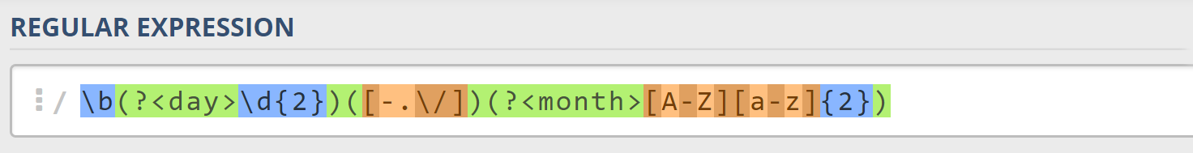
- Next, we're going to match the same separator we matched earlier. We can use a backreference for that:
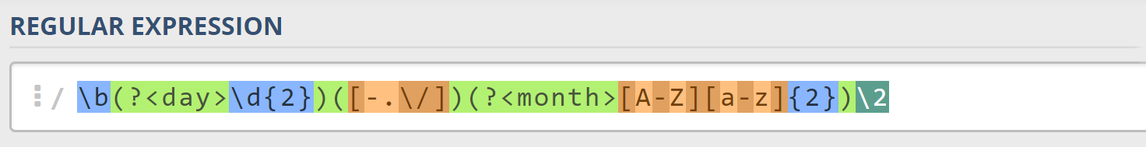
- Next up, we're going to match the year, which consists of exactly 4 digits:
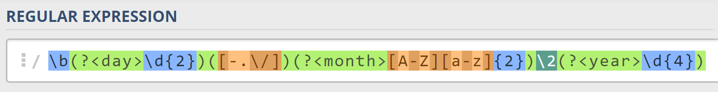
- Finally, since we don't want to match the date if there's anything else glued to it, we're going to use another word boundary for the end:
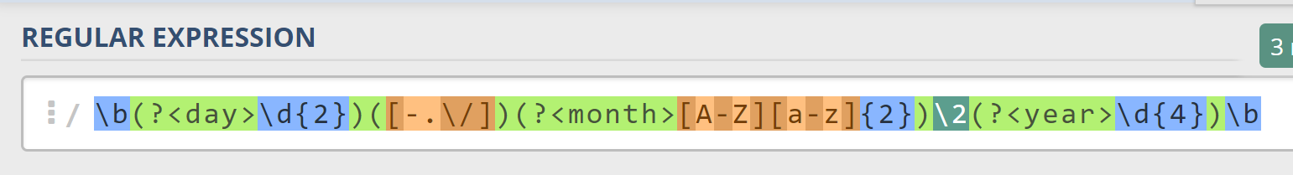
Now it's time to find all the valid dates in the input and print each date in the following format: "Day: {day}, Month: {month}, Year: {year}", each on a new line.

Implement the Solution in JavaScript
First off, we’re going to put our RegEx in a variable and get the matches from the string:
Next, we're going to iterate over every single element in the array and extract the day, month and year by making new patterns and matching them:
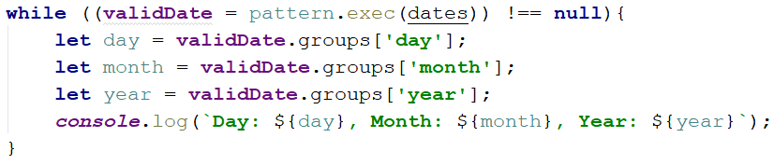

Examples
Input
['13/Jul/1928, 10-Nov-1934, , 01/Jan-1951,f 25.Dec.1937 23/09/1973, 1/Feb/2016']
Output
Day: 13, Month: Jul, Year: 1928
Day: 10, Month: Nov, Year: 1934
Day: 25, Month: Dec, Year: 1937
Input
['1/Jan-1951 23/october/197 11-Dec-2010 18.Jan.2014']
Output
Day: 11, Month: Dec, Year: 2010
Day: 18, Month: Jan, Year: 2014

