Lab: Conditional Statements Advanced
Problems for lab exercise for the "Programming Basics" course @ SoftUni Global
Submit your solutions in the SoftUni Judge system at: https://judge.softuni.org/Contests/4581

Day of Week
Write a program that reads an integer entered by the user and prints the day of the week corresponding to the numbers [1 ... 7] or prints "Error" if the number entered is invalid.

Sample Input and Output
Input | Output
1 | Monday
2 | Tuesday
3 | Wednesday
4 | Thursday
5 | Friday
6 | Saturday
7 | Sunday
-1 | Error

Testing in the Judge System
Test your solution in the online Judge system https://judge.softuni.org/Contests/Compete/Index/4581#0

Weekend or Working Day
Write a program that reads the day of the week (string) - entered by the user. If the day is a working day, it prints on the console - "Working day", if it is a day off - "Weekend". If any text other than the day of the week is entered, print "Error".

Sample Input and Output
Input | Output
Monday | Working day

Input | Output
Sunday | Weekend

Input | Output
April | Error

Testing in the Judge System
Test your solution in the online Judge system https://judge.softuni.org/Contests/Compete/Index/4581#1

Animal Type
Write a program that prints the species of the animal according to its name entered by the user.
- dog -> mammal
- crocodile, tortoise, snake -> reptile
- others -> unknown

Sample Input and Output
Input | Output
dog | mammal
snake | reptile
cat | unknown

Testing in the Judge System
Test your solution in the online Judge system https://judge.softuni.org/Contests/Compete/Index/4581#2

Personal Titles
Write a console program that reads the age (a floating-point number) and gender ("m" or "f") entered by the user and prints an address from the following:
- "Mr." - a man (gender "m") of 16 years or more
- "Master" - a boy (gender "m") under 16 years old
- "Ms." – a woman (gender "f") of 16 years or more
- "Miss" – a girl (gender "f") under 16 years old

Sample Input and Output
Input | Output |  | Input | Output |  | Input | Output |  | Input | Output
12  f | Miss |  | 17  m | Mr. |  | 25  f | Ms. |  | 13.5  m | Master

Hints and Guidelines
- Create variables for age and gender and read their input from the console:
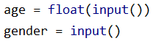
- Checks the gender and then the age. In the body of the if-condition for age print the appropriate output:
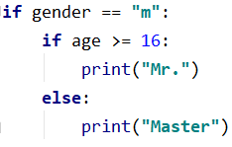 | 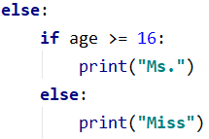
- Start the program with [Ctrl + Shift + F10] and test it with different input values

Testing in the Judge System
Test your solution in the online Judge system https://judge.softuni.org/Contests/Compete/Index/4581#3

Small Shop
- An entrepreneur opens shops in neighborhoods in several cities and sells at different prices:
city / product | coffee | water | beer | sweets | peanuts
London | 0.50 | 0.80 | 1.20 | 1.45 | 1.60
Rome | 0.40 | 0.70 | 1.15 | 1.30 | 1.50
Paris | 0.45 | 0.70 | 1.10 | 1.35 | 1.55
- Write a program that reads product (string), city (string), and quantity (a floating-point number) entered by the user and calculates and prints how much the corresponding quantity of the selected product costs in the specified city.

Sample Input and Output
Input | Output |  | Input | Output |  | Input | Output |  | Input | Output |  | Input | Output
coffee  Paris  2 | 0.9 |  | peanuts  Rome  1 | 1.5 |  | beer  London  3 | 3.6 |  | water  Rome  2 | 1.4 |  | sweets  London  2.23 | 3.2335

Hints and Guidelines
- Create a new file in the PyCharm project;
- Read the input data from the console and create the variable price, by assigning it the value of 0:
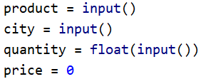
- Make a series of conditions, where in each town you check the product. In each product check, change the value of the price variable and then print it. Take a look at the example below:
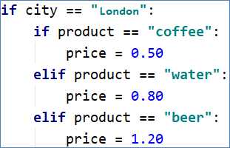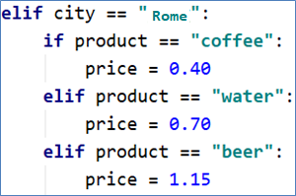

Testing in the Judge System
Test your solution in the online Judge system https://judge.softuni.org/Contests/Compete/Index/4581#4

Number in Range
Write a program that checks if the number entered by the user is in the range [-100, 100] and is different from 0 and print "Yes" if it meets the conditions, or "No" if it is outside the range.

Sample Input and Output
Input | Output |  | Input | Output |  | Input | Output
-25 | Yes |  | 0 | No |  | 25 | Yes

Hints and Guidelines
- Read the integer from the console
- Check whether it is in the interval [-100, 100] and is different from 0, if the condition results in"True", print "Yes", otherwise print "No".
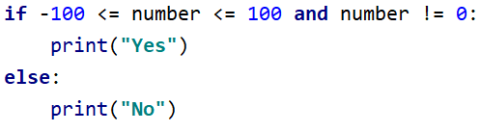

Testing in the Judge System
Test your solution in the online Judge system https://judge.softuni.org/Contests/Compete/Index/4581#5

Working Hours
Write a program that reads an hour of the day (integer) and a day of the week (string) - entered by the user and checks whether the company's office is open, the office hours are from 10:00(10 am) to 18:00(6 pm), from Monday to Saturday including.

Sample Input and Output
Input | Output |  | Input | Output |  | Input | Output
11  Monday | open |  | 19  Friday | closed |  | 11  Sunday | closed

Testing in the Judge System
Test your solution in the online Judge system https://judge.softuni.org/Contests/Compete/Index/4581#6

Cinema Ticket
Write a program that reads the day of the week (string) - entered by the user and prints on the console the price of a movie ticket according to the day of the week:

Sample Input and Output
Monday | Tuesday | Wednesday | Thursday | Friday | Saturday | Sunday
12 | 12 | 14 | 14 | 12 | 16 | 16

Testing in the Judge System
Test your solutions in the online Judge system https://judge.softuni.org/Contests/Compete/Index/4581#7

Fruit or Vegetable
Write a program that reads a product name entered by the user and checks if it is a fruit or vegetable.
- The fruits are banana, apple, kiwi, cherry, lemon, and grapes
- The vegetables are tomato, cucumber, pepper, and carrot
- Everything else is "unknown"
Print "fruit", "vegetable" or "unknown" depending on the introduced product.

Sample Input and Output
Input | Output |  | Input | Output |  | Input | Output |  | Input | Output
banana | fruit |  | apple | fruit |  | tomato | vegetable |  | water | unknown

Testing in the Judge System
Test the solution in the online Judge system: https://judge.softuni.org/Contests/Compete/Index/4581#8

Invalid Number
A number is valid if it is in the range [100… 200] or is 0. Write a program that reads an integer entered by the user and prints "invalid" if the number entered does not meet the criteria.

Sample Input and Output
Input | Output |  | Input | Output |  | Input | Output |  | Input | Output
75 | invalid |  | 150 | (no output) |  | 220 | invalid |  | 199 | (no output)

Input | Output |  | Input | Output |  | Input | Output |  | Input | Output
-1 | invalid |  | 100 | (no output) |  | 200 | (no output) |  | 0 | (no output)

Testing in the Judge System
Test your solution in the online Judge system https://judge.softuni.org/Contests/Compete/Index/4581#9

Fruit Shop
Fruit shop on weekdays works at the following prices:
fruit | banana | apple | orange | grapefruit | kiwi | pineapple | grapes
price | 2.50 | 1.20 | 0.85 | 1.45 | 2.70 | 5.50 | 3.85
On Saturdays and Sundays, the store is works at higher prices:
fruit | banana | apple | orange | grapefruit | kiwi | pineapple | grapes
price | 2.70 | 1.25 | 0.90 | 1.60 | 3.00 | 5.60 | 4.20
Write a program that reads from the console fruit (banana / apple / orange / grapefruit / kiwi / pineapple / grapes), day of the week (Monday / Tuesday / Wednesday / Thursday / Friday / Saturday / Sunday), and quantity (a floating-point number), entered from the customer, and calculates the sum according to the prices in the tables above. In case of an invalid day of the week or invalid fruit name, print "error".

Sample Input and Output
Input | Output |  | Input | Output |  | Input | Output |  | Input | Output |  | Input | Output
apple  Tuesday  2 | 2.40 |  | orange  Sunday  3 | 2.70 |  | kiwi  Monday  2.5 | 6.75 |  | grapes  Saturday  0.5 | 2.10 |  | tomato  Monday  0.5 | error

Testing in the Judge System
Test the solution in the online Judge system: https://judge.softuni.org/Contests/Compete/Index/4581#10

Trade Commissions
The company gives the following commissions to its merchants according to the city in which they operate and the volume of sales:
City | 0 ≤ s ≤ 500 | 500 < s ≤ 1 000 | 1 000 < s ≤ 10 000 | s > 10 000
London | 5% | 7% | 8% | 12%
Paris | 4.5% | 7.5% | 10% | 13%
Rome | 5.5% | 8% | 12% | 14.5%
Write a console program that reads the city name (string) and sales volume (a floating-point number) entered by the user and calculates the percentage of the trade commission according to the table above. Display the result formatted to 2 digits after the decimal point. In case of invalid city or sales volume (negative number) print "error".

Sample Input and Output
Input | Output |  | Input | Output |  | Input | Output |  | Input | Output
London 1500 | 120.00 |  | Rome 499.99 | 27.50 |  | Paris 3874.50 | 387.45 |  | InvalidName  -50 | error

Testing in the Judge System
Test the solution in the online Judge system: https://judge.softuni.org/Contests/Compete/Index/4581#11

