Lab: For-Loop
Problems for lab exercise for the course "Programming Basics" course @ SoftUni Global
Submit your solutions to the SoftUni Judge system: https://judge.softuni.org/Contests/4583

Numbers from 1 to 100
Write a program that prints the numbers from 1 to 100, each on a new line.

Sample Input and Output
Input | Output
(no input) | 1  2  3  …  98  99  100

Hints and Guidelines
Write the solution to the problem by using the code from the picture below:
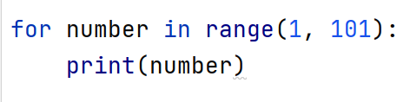

Testing in the Judge System
Test your solution in the online Judge system https://judge.softuni.org/Contests/Compete/Index/4583#0

Numbers 1...N with Step 3
Write a program that reads a number n entered by the user and prints the numbers from 1 to n with step 3.

Sample Input and Output
Input | Output |  | Input | Output |  | Input | Output
10 | 1  4  7  10 |  | 7 | 1  4  7 |  | 15 | 1  4  7  10  13

Hints and Guidelines
- Read the input data from the console - an integer n:
- Create a for-loop from 1 to n (inclusive) and set the step to 3. This means that at each iteration of the loop, the variable i will increase its value by 3 instead of 1. Print the variable at each iteration:
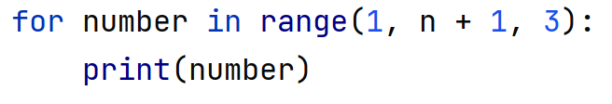

Testing in the Judge System
Test your solution in the online Judge system https://judge.softuni.org/Contests/Compete/Index/4583#1

Even Powers of 2
Write a program that receives a number n and prints the even powers of 2 ≤ 2^{n}: 2⁰, 2², 2⁴, 2⁶, …, 2^{n}.

Sample Input and Output
Input | Output |  | Input | Output |  | Input | Output |  | Input | Output |  | Input | Output
3 | 1  4 |  | 4 | 1  4  16 |  | 5 | 1  4  16 |  | 6 | 1  4  16  64 |  | 7 | 1  4  16  64

Testing in the Judge System
Test your solution in the online Judge system https://judge.softuni.org/Contests/Compete/Index/4583#2

Numbers N…1
Write a program that reads a positive integer n entered by the user and prints the numbers from n to 1 in reverse order. The entered number n will always be greater than 1.

Sample Input and Output
Input | Output |  | Input | Output |  | Input | Output
2 | 2  1 |  | 3 | 3  2  1 |  | 5 | 5  4  3  2  1

Hints and Guidelines
- Read an integer from the console - the count of numbers to be entered.
- Create a for loop from n to 0, decrementing the variable i by 1 at each iteration and printing it.
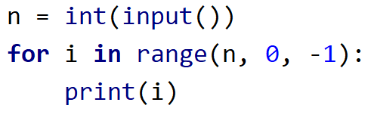

Testing in the Judge System
Test your solution in the online Judge system https://judge.softuni.org/Contests/Compete/Index/4583#3

Character Sequence
Write a program that receives text (string) and prints each character of the string on a separate line.

Sample Input and Output
Input | Output | Input | Output
softuni | s  o  f  t  u  n  i | ice cream | i  c  e  c  r  e  a  m

Hints and Guidelines
To iterate the for loop through the input word in place of the range() function, use directly the variable where you previously stored the input from the console:
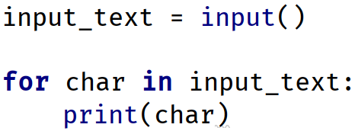

Testing in the Judge System
Test your solution in the online Judge system https://judge.softuni.org/Contests/Compete/Index/4583#4

Vowels Sum
Write a program that reads text (string) entered by the user and calculates and prints the sum of the vowel values according to the table below:
Letter | a | e | i | o | u
Value | 1 | 2 | 3 | 4 | 5

Sample Input and Output
Input | Output | Comments
hello | 6 | e + o = 2 + 4 = 6
hi | 3 | i = 3
bamboo | 9 | a + o + o = 1 + 4 + 4 = 9
beer | 4 | e + e = 2 + 2 = 4

Testing in the Judge System
Test your solution in the online Judge system https://judge.softuni.org/Contests/Compete/Index/4583#5

Sum Numbers
Write a program that reads n number of integers entered by the user and sums them.
- Тhe first line of the input is the count of numbers n to be entered.
- In the next n lines, one integer is entered at a time.
The program has to read the numbers, sum them and print their sum.

Sample Input and Output
Input | Output |  | Input | Output |  | Input | Output |  | Input | Output |  | Input | Output
2  10  20 | 30 |  | 3  -10  -20  -30 | -60 |  | 4  45  -20  7  11 | 43 |  | 1  999 | 999 |  | 0 | 0

Testing in the Judge System
Test your solution in the online Judge system https://judge.softuni.org/Contests/Compete/Index/4583#6

Number sequence
Write a program that reads a number of integers - n. Print the largest and the smallest number among the entered ones.

Sample Input and Output
Input | Output |  | Input | Output
5  10  20  304  0  50 | Max number: 304  Min number: 0 |  | 6  250  5  2  0  100  1000 | Max number: 1000  Min number: 0

Testing in the Judge System
Test your solution in the online Judge system https://judge.softuni.org/Contests/Compete/Index/4583#7

Left and Right Sum
Write a program that reads 2 * n number of integers given by the user and checks if the sum of the first n numbers (left sum) is equal to the sum of the second n numbers (right sum). If equal, prints "Yes, sum = " + sum; otherwise prints "No, diff = " + diff. The difference is calculated as a positive number (in absolute value).

Sample Input and Output
Input | Output | Comments |  | Input | Output | Comments
2  10  90  60  40 | Yes, sum = 100 | 10+90 = 60+40 = 100 |  | 2  90  9  50  50 | No, diff = 1 | 90+9 ≠ 50+50  Difference = |99-100| = 1

Testing in the Judge System
Test your solution in the online Judge system https://judge.softuni.org/Contests/Compete/Index/4583#8

Odd Even Sum
Write a program that reads n number of integers given by the user and checks whether the sum of the numbers in even positions is equal to the sum of the numbers in odd positions.
- If the sums are equal print two lines: "Yes" and on a new line "Sum = " + sum;
- If the sums are not equal print two lines: "No" and on a new line "Diff = " + the difference;
The difference is calculated by absolute value.

Sample Input and Output
Input | Output | Comments |  | Input | Output | Comments |  | Input | Output | Comments
4  10  50  60  20 | Yes  Sum = 70 | 10+60 = 50+20 = 70 |  | 4  3  5  1  -2 | No  Diff = 1 | 3+1 ≠ 5-2  Diff =  |4-3| = 1 |  | 3  5  8  1 | No  Diff = 2 | 5+1 ≠ 8  Diff =  |6-8| = 2

Testing in the Judge System
Test your solution in the online Judge system https://judge.softuni.org/Contests/Compete/Index/4583#9

