Exercise: While Loop
Problems for exercise and homework for the course "Programming Basics" course @ SoftUni Global
Submit your solutions to the Softuni Judge system: https://judge.softuni.org/Contests/4586

Old Books
Annie goes to her hometown after a very long period out of the country. After coming home, she sees her grandmother's old library and remembers her favorite book. Help Annie by writing a program in which she enters the book (string) she is looking for. Until Annie finds her favorite book or checks out all the books in the library, the program must read the name of each following book (string). The books in the library are finished once you get the text "No More Books".
If she does not find the book, print in two lines:
- "The book you search is not here!"
- "You checked {count} books."
If she finds the book, print on a single line:
  - "You checked {count} books and found it."

Sample Input and Output
Input | Output | Comments
Troy  Stronger  Life Style  Troy | You checked 2 books and found it. | The book Annie is looking for in this case is Troy, and the library contains 3 books. The first one is Stronger, the second one is Life Style, the third book is the searched one - Troy and the program ends.
The Spot  Hunger Games  Harry Potter  Torronto  Spotify  No More Books | The book you search for is not here!  You checked 4 books. | The book Annie is looking for is The Spot.  The library contains 4 books.  The first one is Hunger Games, the second one is Harry Potter, the third one is Torronto, and the fourth one is Spotify. Since there are no more books in the library, the name reading finished. Annie didn't find the book she was looking for.
Bourne  True Story  Forever  More Space  The Girl  Spaceship  Strongest  Profit  Tripple  Stella  The Matrix  Bourne | You checked 10 books and found it.

Hints and Guidelines
- Read the input data from the console:
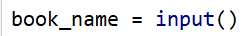
- Make two more helper variables at the beginning:
  - one will be a counter (of integer type and with an initial value of zero), which will keep track of how many books have been checked;
  - the other variable must be of boolean type and have an initial value False.
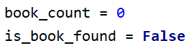
- Make a while loop where you read a new book from the console each time until the books in the library run out and read the text "No More Books".
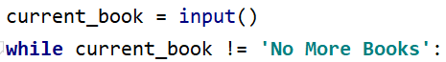
- Make a check - if the book you are reading from the console matches Annie's favorite book, change the value of the boolean variable to True, print and exit the loop. Otherwise, increment the counter by one:
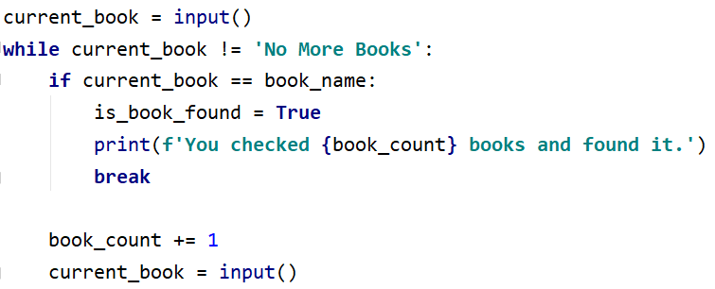
- According to whether the book is not found, print the necessary messages:
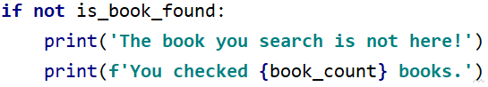

Testing in the Judge System
Test your solution in the online Judge system: https://judge.softuni.org/Contests/Compete/Index/4586#0

Exam Preparation
Write a program with which Michael solves problems from his exams until he receives the "Enough" command from his lecturer. For each problem he solves, he receives a grade. The program should finish when receiving the "Enough" command or if Michael receives the specified number of poor grades.
A poor grade is any grade that is less than or equal to 4.

Input Data
- On the first line - number of poor grades – an integer;
- Then multiple readings of two lines:
  - Problem name – string
- Grade – an integer in the range [2…6]

Output Data
- If Michael receives the "Enough" command, print on 3 lines:
- "Average score: {average score}"
- "Number of problems: {number of all problems}"
  - "Last problem: {last problem name}"
- If he receives the specified number of poor grades:
- "You need a break, {number of poor grades} poor grades."
The average score must be formatted to two digits after the decimal point.

Sample Input and Output
Input | Output | Comments
3  Money  6  Story  4  Spring Time  5  Bus  6  Enough | Average score: 5.25  Number of problems: 4  Last problem: Bus | The number of poor grades allowed is 3.  The first problem is called Money, Michael's grade is 6.  The second problem is Story, Michael's grade is 4.  The third problem is Spring Time, Michael's grade is 5.  The fourth problem is Bus, Michael's grade is 6.  The next command is Enough, and the program ends.  Average score: 21 / 4 = 5.25  Number of solved problems: 4  Last problem: Bus
Input | Output | Comments
2  Income  3  Game Info  6  Best Player  4 | You need a break, 2 poor grades. | The number of poor grades allowed is 2.  The first problem is called Income, Michael's grade is 3.  The second problem is Game Info, Michael's grade is 6.  The third problem is Best Player, Michael's grade is 4.  Michael has reached the allowed number of poor grades, time for a break.

Hints and Guidelines
- Read the input data from the console:
- Make five helper variables at the beginning:
- counter for solved problems - with an initial value of 0;
- counter for poor grades – with an initial value of 0;
- sum of all grades - with initial value 0;
- which is the last problem - with initial value blank text;
- whether or not he failed;
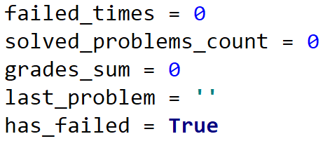
- Create a while loop that continues until the number of poor grades is less than the number you read from the console. On each iteration of the loop, read the name of the problem and its grade.
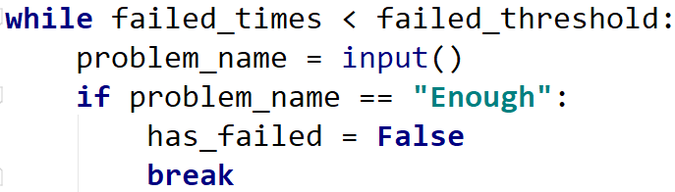
- In case you receive an Enough command change the value of has_failed to False and break the loop;
- At each loop iteration, add Marin's grade to the sum of all his grades and increase the problems counter. If the grade is less than or equal to 4 increase the counter for poor grades. Rewrite the name of the last problem;
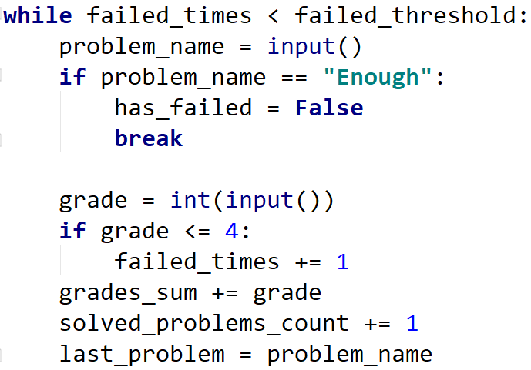
- After the loop, if the number of poor grades has reached the maximum poor grades, print the appropriate message:
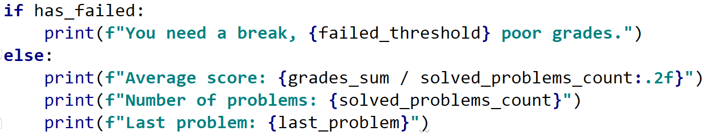

Testing in the Judge System
Test your solution in the online Judge system: https://judge.softuni.org/Contests/Compete/Index/4586#1

Vacation
Jessie has decided to raise money for a vacation and wants you to help her find out if she will be able to collect the required amount. She saves or spends some of her money every day. If she wants to spend more than her available money, she will spend everything she has and will be left with 0 USD.

Input Data
From the console read:
- Money needed for the vacation – a floating-point number.
- Available money – a floating-point number.
Then 2 lines are read multiple times:
- Action type – text with "spend" and "save" options.
  - Amount to save/spend – a floating-point number.

Output Data
The program must end in the following cases:
- If in 5 consecutive days Jessie only spends, the console displays:
- "You can't save the money."
- "{Total days passed}"
- If Jessie collects the money for the vacation, the console displays:
- "You saved the money for {Total days passed} days."

Sample Input and Output
Input | Output | Comments
2000  1000  spend  1200  save  2000 | You saved the money for 2 days. | Money needed for the vacation: 2000  Available money: 1000  spend - subtract the next number from the money  (1000 - 1200 = -200, which is less than 0  => available money = 0)  ~ consecutive days spend = 1  - total days: 1  save - add the next number to the money  (0 + 2000 = 2000)  ~ consecutive days spend = 0  - total days: 2  Available money (2000) >= Money needed for the vacation (2000)
110  60  spend  10  spend  10  spend  10  spend  10  spend  10 | You can't save the money.  5 | Money needed for the vacation: 110  Available money: 60  spend – subtract the next number from the money (60 - 10 = 50)  ~ consecutive days spend = 1  - total days: 1  spend – subtract the next number from the money (50 - 10 = 40)  ~ consecutive days spend = 2  - total days: 2  spend – subtract the next number from the money (40 - 10 = 30)  ~ consecutive days spend = 3  - total days: 3  spend – subtract the next number from the money (30 - 10 = 20)  ~ consecutive days spend = 4  - total days: 4  spend – subtract the next number from the money (20 - 10 = 10)  ~ consecutive days spend = 5  - total days: 5  5 consecutive days spend => available money: 10  Available money (10) < Money needed for the vacation (110)
250  150  spend  50  spend  50  save  100  save  100 | You saved the money for 4 days. | Money needed for the vacation: 250  Available money: 150  spend - subtract the next number from the money (150 - 50 = 100)  ~ consecutive days spend = 1  - total days: 1  spend - subtract the next number from the money (100 - 50 = 50)  ~ consecutive days spend = 2  - total days: 2  save - add the next number to the money (50 + 100 = 150)  ~ consecutive days spend = 0  - total days: 3  save - add the next number to the money (150 + 100 = 250)  ~ consecutive days spend = 0  - total days: 4  Available money (250) >= Money needed for the vacation (250)

Hints and Guidelines
- Read the input data from the console:
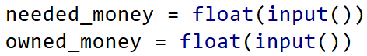
- Make two helper variables at the beginning to keep track of the number of days passed and the number of consecutive days Jesse spends money. Let both variables have an initial value of zero:
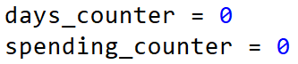
- Create a while loop that continues until Jessie's money is less than the money she needs for the trip and the counter for consecutive days is less than 5. At each iteration of the loop, read two lines from the console - the first line is text - spend or save, and the second is the money Jessie has saved or spent. Also, increase the days counter by 1:
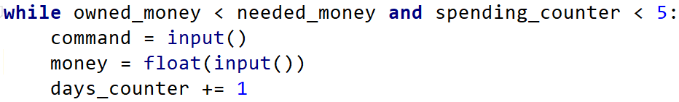
- Check whether Jessie is spending or saving for the day:
  - If she saves, add the money saved to hers and reset the counter for consecutive days;
  - If she spends, subtract from her money the amount she spent and increase the counter for the consecutive days she spends. Check if Jessie's money has become less than zero and if so, she is out of money and has zero leva;
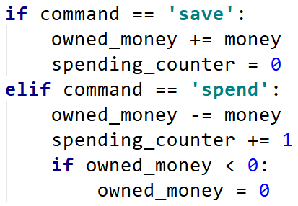
- After the loop, check whether Jessie has spent money on five consecutive days and print the message. Also check whether Jessie has collected the money and, if she has, print the appropriate message
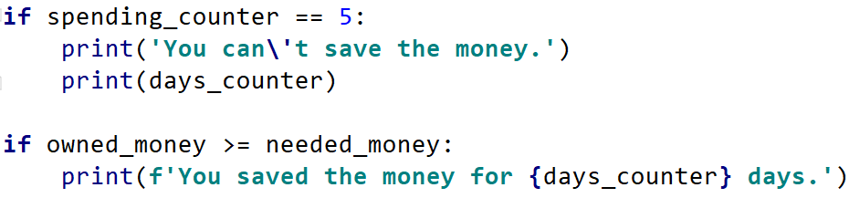

Testing in the Judge System
Test your solution in the online Judge system: https://judge.softuni.org/Contests/Compete/Index/4586#2

Walking
Emma wants to start a healthy lifestyle and has set a goal to walk 10,000 steps every day. However, some days she is very tired from work and will get home before she reaches her goal. Write a program that reads from the console how many steps she walks each time she goes out during the day, and when she reaches her goal, print "Goal reached! Good job!" and how many more steps she has walked "{difference between steps} steps over the goal!"
If she wants to go home before then, she will enter the command "Going home" and enter the steps she has walked while going home. If she hasn’t reached 10,000 steps, print how many more steps she needs: "{difference between steps} more steps to reach the goal."

Sample Input and Output
Input | Output | Input | Output
1000  1500  2000  6500 | Goal reached! Good job!  1000 steps over the goal! | 1500  300  2500  3000  Going home  200 | 2500 more steps to reach goal.
Input | Output | Input | Output
1500  3000  250  1548  2000  Going home  2000 | Goal reached! Good job!  298 steps over the goal! | 125  250  4000  30  2678  4682 | Goal reached! Good job!  1765 steps over the goal!

Testing in the Judge System
Test your solution in the online Judge system: https://judge.softuni.org/Contests/Compete/Index/4586#3

Coins
Vending machine manufacturers wanted to make their machines return as few change coins as possible. Write a program that receives an amount - the change that needs to be returned and calculates the minimum number of coins required. The coins can be 2.00 EUR, 1.00 EUR, 0.50 EUR, 0.20 EUR, 0.10 EUR, 0.05 EUR, 0.02 EUR, 0.01 EUR.

Sample Input and Output
Input | Output | Comments
1.23 | 4 | Our change is 1,23 EUR. The machine returns it to us with 4 coins: a coin of 1 EUR, a coin of 0.20 EUR, a coin of 0.02 EUR, and a coin of 0.01 EUR.
2 | 1 | Our change is 2.00 EUR. The machine returns it to us with 1 coin of 2 EUR.
0.56 | 3 | Our change is 0.56 EUR. The machine returns it to us with 3 coins: a coin of 0.50 EUR, a coin of 0.05 EUR, and a coin of 0.01 EUR.
2.73 | 5 | Our change is 2.73 EUR. The machine returns it to us with 5 coins: a coin of 2 EUR, a coin of 0.50 EUR, a coin of 0.20 EUR, a coin of 0.02 EUR, and a coin of 0.01 EUR.

Testing in the Judge System
Test your solution in the online Judge system: https://judge.softuni.org/Contests/Compete/Index/4586#4

Cake
You're invited to a 30th birthday party, where the birthday boy serves a huge cake. However, he doesn't know how many pieces the guests can take from it. Your task is to write a program that calculates the number of pieces the guests have taken before it is eaten. You will receive the dimensions of the cake (width and length – integers) and then on each line until you receive the "STOP" command or until the cake is finished, the number of pieces the guests take from it. Each piece of cake is 1x1 cm.
Print one of the following lines on the console:
- "{number of pieces} pieces are left." - if you receive STOP and have not finished the cake pieces
- "No more cake left! You need {number of not enough pieces} pieces more."

Sample Input and Output
Input | Output | Comments
10  10  20  20  20  20  21 | No more cake left! You need 1 pieces more. | The cake is 10 cm long and 10 cm wide  => number of pieces = 10 * 10 = 100  1st take -> 100 - 20 = 80  2nd take -> 80 - 20 = 60  3rd take -> 60 - 20 = 40  4th take -> 40 - 20 = 20  5th take -> 20 - 21 = -1 < 0  => no more cake left, 1 piece is not enough
10  2  2  4  6  STOP | 8 pieces are left. | The cake is 10 cm long and 2 cm wide  => number of pieces = 10 * 2 = 20  1st take -> 20 - 2 = 18  2nd take -> 18 - 4 = 14  3rd take -> 14 - 6 = 8  4th take -> command STOP  => pieces left: 8

Testing in the Judge System
Test your solution in the online Judge system: https://judge.softuni.org/Contests/Compete/Index/4586#5

Moving
On Jose's eighteenth birthday, he decided that he was going to move out to live in an apartment. He packed his stuff in boxes and found an ad for a suitable apartment to rent. He began moving his stuff in pieces because he couldn't carry it all at once. He has limited free space in his new apartment where he can place his stuff so that the place is suitable for living.
Write a program that calculates the free volume of Jose's apartment that remains after he moves his stuff.
Each box is of exact size: 1m. x 1m. x 1m.

Input Data
The user enters the following data on separate lines:
- Free space width - an integer
- Free space length - an integer
- Free space height - an integer
- On the next lines (until the "Done" command is received) – the number of boxes to be moved to the apartment - integers
The program should stop when receiving the "Done" command or if the free space runs out.

Output Data
Print one of the following lines on the console:
- If you receive the "Done" command and there is still space available:
"{number of free cubic meters} Cubic meters left."
- If the free space runs out before the "Done" command is received:
"No more free space! You need {number of not enough cubic meters} Cubic meters more."

Sample Input and Output
Input | Output | Comments
10  10  2  20  20  20  20  122 | No more free space! You need 2 Cubic meters more. | 10 * 10 * 2 = 200 cubic meters available  20 + 20 + 20 + 20 + 122 = 202 cubic meters  200 - 202 = 2 needed cubic meters
10  1  2  4  6  Done | 10 Cubic meters left. | 10 * 1 * 2 = 20 cubic meters available  4 + 6 = 10 cubic meters  20 - 10 = 10 cubic meters

Testing in the Judge System
Test your solution in the online Judge system: https://judge.softuni.org/Contests/Compete/Index/4586#6

