Lab: Conditional Statements
Problems for lab exercise for the "Programming Basics" course @ SoftUni Global
Submit your solutions to the SoftUni Judge system: https://judge.softuni.org/Contests/4579

Excellent Result
Write a console program that reads a rating (floating-point number) entered by the user and prints "Excellent!" if the score is 5.50 or higher.
Input | Output |  | Input | Output |  | Input | Output |  | Input | Output
6 | Excellent! |  | 4 | (no output) |  | 5.50 | Excellent! |  | 5.49 | (no output)

Hints and Guidelines:
- Create a Python file with an appropriate name, for example, excellent_grade. Create a variable, which will hold the floating-point number– the grade, which will be read from the console:
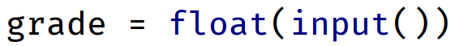
Check the value of the grade. If it is greater than or equal to 5.50, print the conditional output 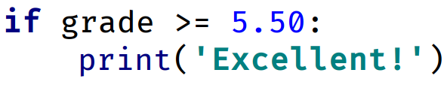
- Start the program with [Ctrl + Shift + F10] and test it with different input values:
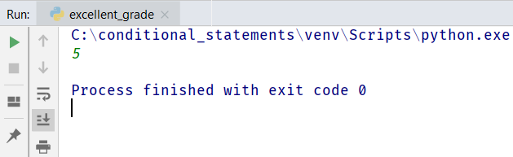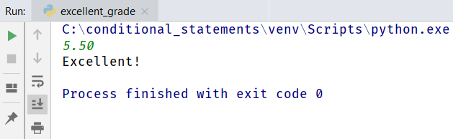

Testing in the Judge System
Test your solutions in the online Judge system https://judge.softuni.org/Contests/Compete/Index/4579#0

Greater Number
Write a program that reads two integers entered by the user and prints the larger of the two.

Sample Input and Output
Input | Output |  | Input | Output |  | Input | Output |  | Input | Output
5  3 | 5 |  | 3  5 | 5 |  | 10  10 | 10 |  | -5  5 | 5

Hints and Guidelines
- Create a Python file with an appropriate name in the project
- Read two integers from the console:
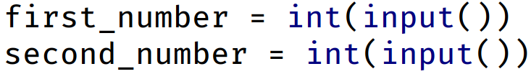
- Compare whether the first_number is greater than second_number. Print the larger number.
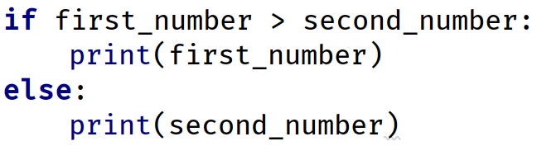

Testing in the Judge System
Test your solutions in the online Judge system https://judge.softuni.org/Contests/Compete/Index/4579#1

Even or Odd
Write a program that reads an integer entered by the user and prints whether it is even or odd.

Sample Input and Output
Input | Output |  | Input | Output |  | Input | Output |  | Input | Output
2 | even |  | 3 | odd |  | 25 | odd |  | 1024 | even

Hints and Guidelines
- Create a Python file with an appropriate name in the project;
- Read an integer from the console
- Check that the number is even by dividing it by 2, and check what the remainder of the division is. Print the output depending on the condition:
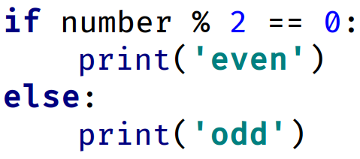

Testing in the Judge System
Test your solutions in the online Judge system https://judge.softuni.org/Contests/Compete/Index/4579#2

Password Guess
Write a program that reads a password (string) entered by the user and checks if the entered password matches the phrase "s3cr3t!P@ssw0rd". In case of coincidence, display "Welcome". In case of discrepancy, display "Wrong password!".

Sample Input and Output
Input | Output |  | Input | Output |  | Input | Output
qwerty | Wrong password! |  | s3cr3t!P@ssw0rd | Welcome |  | s3cr3t!p@ss | Wrong password!

Testing in the Judge System
Test your solutions in the online Judge system https://judge.softuni.org/Contests/Compete/Index/4579#3

Numbers from 100 to 200
Write a program that reads an integer entered by the user and checks if it is below 100, between 100 and 200 or above 200. If the number is:
- below 100 print: "Less than 100"
- between 100 and 200 print: "Between 100 and 200"
- above 200 print: "Greater than 200"

Sample Input and Output
Input | Output |  | Input | Output |  | Input | Output
95 | Less than 100 |  | 120 | Between 100 and 200 |  | 210 | Greater than 200

Testing in the Judge System
Test your solutions in the online Judge system https://judge.softuni.org/Contests/Compete/Index/4579#4

Speed Info
Write a program that reads the speed (floating-point number) entered by the user and prints speed information.
- At speed up to 10 (inclusive) print "slow"
- At speed between 10 and 50 (inclusive) print "average"
- At speed between 50 and 150 (inclusive) print "fast"
- At speed between 150 and 1000 (inclusive) print "ultra fast"
- At a higher speed print "extremely fast"

Sample Input and Output
Input | Output |  | Input | Output |  | Input | Output |  | Input | Output |  | Input | Output
8 | slow |  | 49.5 | average |  | 126 | fast |  | 160 | ultra fast |  | 3500 | extremely fast

Testing in the Judge System
Test your solutions in the online Judge system https://judge.softuni.org/Contests/Compete/Index/4579#5

Area of Figures
Write a program in which the user enters the type and dimensions of a geometric figure and calculates its area. The figures are of four types: square, rectangle, circle, and triangle. The first line of the input reads the type of figure (string with the following options: square, rectangle, circle, or triangle).
- If the figure is a square: on the next line read a floating-point number - the length of its side
- If the figure is a rectangle: on the next two lines read two floating-point numbers - the lengths of its sides
- If the figure is a circle: on the next line read a floating-point number - the radius of the circle
- If the figure is a triangle: on the next two lines read two floating-point numbers - the length of its side and the length of the height to it
Round the result up to 3 digits after the decimal point.

Sample Input and Output
Input | Output |  | Input | Output |  | Input | Output |  | Input | Output
square  5 | 25.000 |  | rectangle  7  2.5 | 17.500 |  | circle  6 | 113.097 |  | triangle  4.5  20 | 45.000

Testing in the Judge System
Test your solutions in the online Judge system https://judge.softuni.org/Contests/Compete/Index/4579#6

