Exercises: Heaps and BST
This document defines the lab for "Data Structures – Fundamentals (Java)" course @ Software University. Please submit your solutions (source code) of all below described problems in Judge.
Write Java code for solving the tasks on the following pages. Code should compile under the Java 8 and above standards you can write and locally test your solution with the Java 13 standard, however Judge will run the submission with Java 10 JRE. Avoid submissions with features included after Java 10 release doing otherwise will result in compile time error.
Any code files that are part of the task are provided as Skeleton. In the beginning import the project skeleton, do not change any of the interfaces or classes provided. You are free to add additional logic in form of methods in both interfaces and implementations you are not allowed to delete or remove any of the code provided. Do not change the names of the files as they are part of the tests logic. Do not change the packages or move any of the files provided inside the skeleton if you have to add new file add it in the same package of usage.
Some tests may be provided within the skeleton – use those for local testing and debugging, however there is no guarantee that there are no hidden tests added inside Judge.
Please follow the exact instructions on uploading the solutions for each task. Submit as .zip archive the files contained inside "...\src\main\java" folder this should work for all tasks regardless of current DS implementation.
In order for the solution to compile the tests successfully the project must have single Main.java file containing single public static void main(String[] args) method even empty one within the Main class.
Some of the problem will have simple Benchmark tests inside the skeleton. You can try to run those with different values and different implementations in order to observe behaviour. However keep in mind that the result comes only as numbers and this data may be misleading in some situations. Also the tests are not started from the command prompt which may influence the accuracy of the results. Those tests are only added as an example of different data structures performance on their common operations.
The Benchmark tool we are using is JMH (Java Microbenchmark Harness) and that is Java harness for building, running, and analyzing, nano/micro/milli/macro benchmarks written in Java and other languages targeting, the JVM.
Additional information can be found here: JMH and also there are other examples over the internet.
Important: when importing the skeleton select import project and then select from maven module, this way any following dependencies will be automatically resolved. The project has NO default version of JDK so after the import you may (depends on some configurations) need to specify the SDK, you can download JDK 13 from HERE.

BST Operations
You are given a skeleton, in which you will have to implement the following operations:
- void insert(E) – Recursive implementation
- void eachInOrder(Consumer<E>) – In-Order traversal
- bool contains(E) – Iterative implementation
- BST<E> search(E) – Returns copy of the BST
- List<E> range(E, E) – Returns collection with the elements found in the BST. Both borders are inclusive.
- deleteMin() – Deletes the smallest element in the tree. Throws exception if the tree is empty.
You can reuse the solution from the Lab we had and only add implementations for the new methods. However it is indeed a good idea to try implementing those methods again, repetition will give you better understanding and you can choose some different approach.

Implement additional methods described below:

Delete Max
Implement a method which deletes the max element in a BST (Binary Search Tree). If the tree is empty it should throw exception IllegalArgumentException. The logic is similar to the deleteMin() method, but you need to traverse the tree to the right.

Count
Implement a method which returns the count of elements in the BST.

Hints
If our current node is null, we will return 0. Otherwise, we will return the count of our current node:
We also have to modify our insert() method. It will set the count of elements of our new node to the count of its children nodes plus itself:
Next, we need to find a way to update the recalculate the count for each node when deleteMin() is invoked. One way would be to change the deleteMin() implementation to be recursive:
What will happen if our tree is empty and we call deleteMin()? Fix it. Our count is ready.

Rank
Implement a method which returns the count of elements smaller than a given value.

Hints
Create a new recursive method that will return 0 if the node is null:
Then, we need to compare the element with the value of the node we are currently looking at. If the element is smaller, we can go to the left. If it is larger, we need to get the count of the left elements and go to the right. If we find the element, we will return the count of elements, smaller than it.
You can try it out, it should work as expected.

Floor
Implement a method which finds (returns) the nearest smaller value than given in the BST. This operation is similar to deleteMin().

Ceiling
Implement a method which finds (returns) the nearest larger value than given in the BST. This operation is similar to floor() and deleteMax().

Lowest Common Ancestor
You are given the binary tree and two values V₁ and V₂. You need to return the lowest common ancestor (LCA) of V₁ and V₂ in the binary tree. Note that lowest here means in terms of level distance. The close the node is to both values the lower we say it is. In other words you can ignore the value you should only care for the distance.
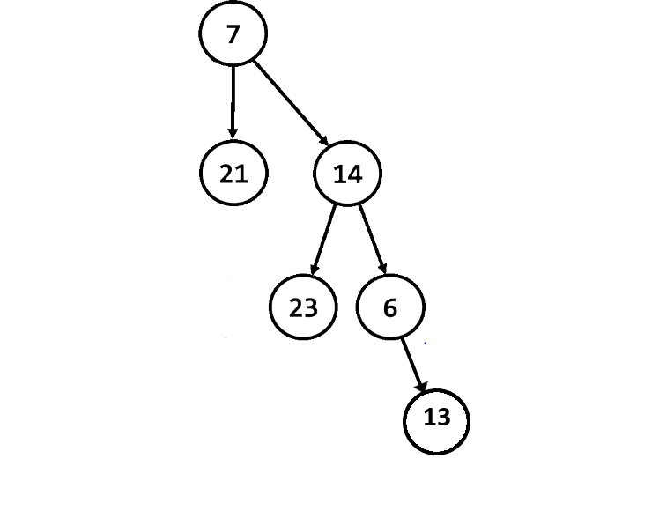
In the given tree above the lowest common ancestor of the nodes 23 and 13 is the node 14. Node 14 is the lowest node which has nodes 23 and 13 as descendants.

Min Heap
Based on the implementation of the MaxHeap<E> and ADS Heap<E> from the lab implement data structure that acts and operates the same way, however this time the heap property you want to preserve is the Min heap property.
You will be given no hints here since the solution is really similar to the one from the lab.
Remember you have to throw IllegalStateException if you attempt to peek () or poll () on empty heap.
In addition poll () should simply remove the element at the top of the heap (remember how PriorityQueue worked).
If you get stuck remember you have all the code inside the lab resources.

Decrease Key
Extend your Min Heap to support the decrease (E element) operation that changes the priority of a given key. In a Min Heap this should increase the priority of a given key, moving it higher in the tree structure, e.g. decreasing the price of a given product, increases its priority for the customers. Study the code provided you have to focus on the implementation of that method everything else is provided.

Cookies
We want the sweetness of all his cookies to be greater than value K. To do this, we need to repeatedly mix two cookies with the least sweetness. We creates a special combined cookie with sweetness calculated by:
- (least sweet cookie) + (2 * 2nd least sweet cookie).
We repeats this procedure until all the cookies in the collection have a sweetness not less than K.
You are given the cookies. Return the number of operations required to give the cookies a sweetness not less than K. Return -1 if this isn't possible.
Implement the Integer solve (int k, int[] cookies) method inside the provided CookiesProblem class.

Input
Study the tests provided. Basically the first parameter is the K value and the second one is the array representing the cookies.
The first line consists of integers, the number of cookies and, the minimum required sweetness, separated by a space.

Output
The method should return a single integer -1 if there is no solution. Otherwise return the number of operations required to complete the task.
Input | Output
7  1 2 3 9 10 12 | 2

Top View
You are given the binary tree. Print the top view of the binary tree. More info can be fund here.
Top view means when you look the tree from the top the nodes, what you will see will be called the top view of the tree. See the example below.

Examples
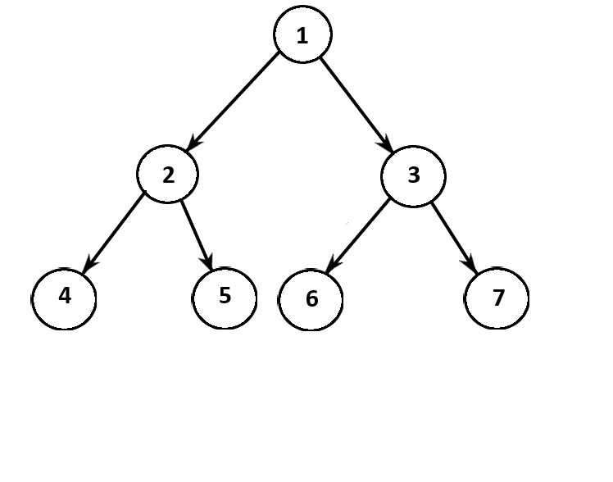
Given the above tree the result should be: 1, 2, 4, 3, 7, where order of output does not matter.

“In the beginning there was nothing, which exploded.”
― Terry Pratchett, Lords and Ladies

