Algorithms with Java: Exam Preparation
This document defines the exam preparation for "Algorithms – Fundamentals (Java)" course @ Software University. Please submit your solutions (source code) of all below described problems in Judge.

Le Tour de Sofia
Pierre is training for the famous bicycle tour of Sofia. He is a cyclist, the laziest at that, and he is planning a workout route…the shortest one.
You are given all junctions and all one-way streets in Sofia. Help Pierre find the length of the shortest route starting at a given junction and ending back there. If there is no such route print the numbers of junctions reachable from the start.

Input
- The first line holds an integer n – the number of junctions
- On the second line, you will receive the number m – the number of streets
- On the third line, s - the start of the route
- At the next m lines, you will receive the streets in the format: {from junction} {to junction}

Output
- If there is a route from the start and back to it, print the length of the route
- If there is no such a route, print the count of reachable junctions from the start

Constraints
- Number of junctions will be an integer in the range [0…10000]
- Number of streets will be an integer in the range [0…10000]
- All junctions will be numbered from 0 to N - 1.
- Time limit: 100 ms. Allowed memory: 20 MB

Examples
Input | Output | Visual | Comment
7  10  0  0 2  2 1  1 0  3 0  3 1  2 4  3 4  4 5  5 6  6 3 | 3 | 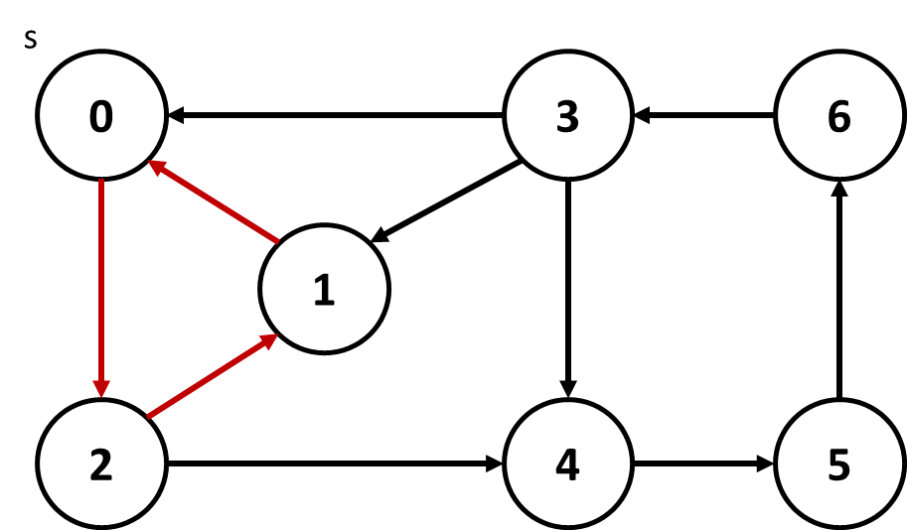 | The shortest route starting at 0 is:  0 2 1 0  It has length of 3
3  2  1  0 1  1 2 | 2 | 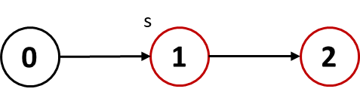 | There is no route for Pierre. Junctions that can be reached: 1, 2

