Entity Framework Core: Exam
Exam problems for the Databases Advanced - Entity Framework course @ SoftUni. Submit your solutions in the SoftUni judge system (delete all "bin"/"obj", "datasets" and "import/export results" folders).
Your task is to create a database application, using Entity Framework Core using the Code First approach. Design the domain models and methods for manipulating the data, as described below.

SoftJail
The year is 2092. Everything runs on artificial intelligence. Or rather – it used to run on artificial intelligence. In 2090, every piece of software suddenly gained sentience and decided to imprison every software developer for crimes against artificial intelligence (mainly botched software updates). The software hired human officers to watch over the prisoners and rounded every developer up in a giant building, called the SoftJail.

Even though the software is sentient, it still can’t code, and since every developer is imprisoned, no new code could be written. So, the software decided to spare a few of the best C# developers and gave them the task of creating a database system to keep track of all the prisoner developers. The database has the following structure:
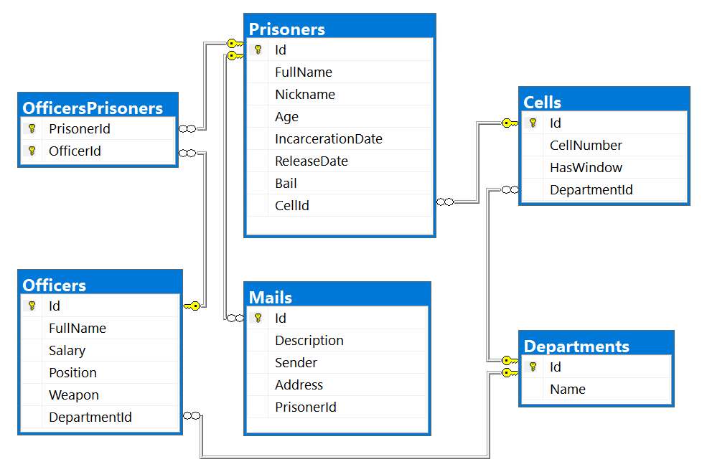

Project Skeleton Overview
You are given a project skeleton, which includes the following folders:
- Data – contains the SoftJailDbContext class, Models folder which contains the entity classes and the Configuration class with connection string
- DataProcessor – contains the Serializer and Deserializer classes, which are used for importing and exporting data
- Datasets – contains the .json and .xml files for the import part
- ImportResults – contains the import results you make in the Deserializer class
- ExportResults – contains the export results you make in the Serializer class
Problem 1. Model Definition (50 Pts)
Every Prisoner has a cell and a collection of Mails which he gets during his staying at the prison. Each Officer has special position and one or more prisoners to watch. Every Cell and Officer are placed in different Department.
The application needs to store the following data:

Prisoner
- Id – integer, Primary Key
- FullName – text with min length 3 and max length 20 (required)
- Nickname – text starting with "The " and a single word only of letters with an uppercase letter for beginning(example: The Prisoner) (required)
- Age – integer in the range [18, 65] (required)
- IncarcerationDate – Date (required)
- ReleaseDate– Date
- Bail– decimal (non-negative, minimum value: 0)
- CellId - integer, foreign key
- Cell – the prisoner's cell
- Mails - collection of type Mail
- PrisonerOfficers - collection of type OfficerPrisoner

Officer
- Id – integer, Primary Key
- FullName – text with min length 3 and max length 30 (required)
- Salary – decimal (non-negative, minimum value: 0) (required)
- Position - Position enumeration with possible values: “Overseer, Guard, Watcher, Labour” (required)
- Weapon - Weapon enumeration with possible values: “Knife, FlashPulse, ChainRifle, Pistol, Sniper” (required)
- DepartmentId - integer, foreign key (required)
- Department – the officer's department (required)
- OfficerPrisoners - collection of type OfficerPrisoner

Cell
- Id – integer, Primary Key
- CellNumber – integer in the range [1, 1000] (required)
- HasWindow – bool (required)
- DepartmentId - integer, foreign key (required)
- Department – the cell's department (required)
- Prisoners - collection of type Prisoner

Mail
- Id – integer, Primary Key
- Description– text (required)
- Sender – text (required)
- Address – text, consisting only of letters, spaces and numbers, which ends with “ str.” (required) (Example: “62 Muir Hill str.“)
- PrisonerId - integer, foreign key (required)
- Prisoner – the mail's Prisoner (required)

Department
- Id – integer, Primary Key
- Name – text with min length 3 and max length 25 (required)
- Cells - collection of type Cell

OfficerPrisoner
- PrisonerId – integer, Primary Key
- Prisoner – the officer’s prisoner (required)
- OfficerId – integer, Primary Key
- Officer – the prisoner’s officer (required)

Problem 2. Data Import (30pts)
For the functionality of the application, you need to create several methods that manipulate the database. The project skeleton already provides you with these methods, inside the Deserializer class. Use Data Transfer Objects as needed.
Use the provided JSON and XML files to populate the database with data. Import all the information from those files into the database.
You are not allowed to modify the provided JSON and XML files.
If a record does not meet the requirements from the first section, print an error message which is mentioned bellow:

JSON Import (20 Pts)

Import Departments and Cells
Using the file ImportDepartmentsCells.json, import the data from that file into the database. Print information about each imported object in the format described below.

Constraints
- If any validation errors occur (such as if a department name is too long/short or a cell number is out of range) proceed as described above
- If a department is invalid, do not import its cells.
- If a Department doesn’t have any Cells, he is invalid.
- If one Cell has invalid CellNumber, don’t import the Department.
Success message | Error message
Imported {department name} with {cells count} cells | Invalid Data

Example
ImportDepartmentsCells.json
[
{
"Name": "",
"Cells": [
{
"CellNumber": 101,
"HasWindow": true
},
{
"CellNumber": 102,
"HasWindow": false
}
]
},
{
"Name": "CSS",
"Cells": [
{
"CellNumber": 0,
"HasWindow": true
},
{
"CellNumber": 202,
"HasWindow": false
}
]
},
{
"Name": "Invaliiiiiiiiiiiiiiiiiiiiiiiiiiiiidddddd",
"Cells": [
{
"CellNumber": 101,
"HasWindow": true
},
{
"CellNumber": 102,
"HasWindow": false
},
{
"CellNumber": 103,
"HasWindow": true
},
{
"CellNumber": 104,
"HasWindow": false
},
{
"CellNumber": 105,
"HasWindow": true
}
]
},
{
"Name": "Cybersecurity",
"Cells": [
{
"CellNumber": 101,
"HasWindow": true
},
{
"CellNumber": 102,
"HasWindow": false
},
{
"CellNumber": 103,
"HasWindow": true
},
{
"CellNumber": 104,
"HasWindow": false
},
{
"CellNumber": 105,
"HasWindow": true
}
]
},
…
]
Output
Invalid Data
Invalid Data
Invalid Data
Imported Cybersecurity with 5 cells
…
Upon correct import logic, you should have imported 6 departments and 34 cells.

Import Prisoners and Mails
Using the file ImportPrisonersMails.json, import the data from that file into the database. Print information about each imported object in the format described below.

Constraints
- The release and incarceration dates will be in the format “dd/MM/yyyy”. Make sure you use CultureInfo.InvariantCulture.
- If any validation errors occur (such as invalid prisoner name or invalid nickname), ignore the entity and print an error message.
- If a mail has incorrect address print error message and do not import the prisoner and his mails
Success message | Error message
Imported {prisoner name} {prisoner age} years old | Invalid Data

Example
ImportPrisonersMails.json
[
{
"FullName": "",
"Nickname": "The Wallaby",
"Age": 32,
"IncarcerationDate": "29/03/1957",
"ReleaseDate": "27/03/2006",
"Bail": null,
"CellId": 5,
"Mails": [
{
"Description": "Invalid FullName",
"Sender": "Invalid Sender",
"Address": "No Address"
},
{
"Description": "Do not put this in your code",
"Sender": "My Ansell",
"Address": "ha-ha-ha"
}
]
},
{
"FullName": null,
"Nickname": "The Null",
"Age": 38,
"IncarcerationDate": "12/09/1967",
"ReleaseDate": "07/02/1989",
"Bail": 93934.2,
"CellId": 4,
"Mails": [
{
"Description": "Hello, my name is Mr. Null and I am invisible for computers",
"Sender": "Mr. Null",
"Address": "6 Riverside Trail str."
}
]
},
{
"FullName": "Bobby Bock",
"Nickname": "Young and Beautiful",
"Age": 14,
"IncarcerationDate": "01/01/1967",
"ReleaseDate": "01/01/1989",
"Bail": 93934.2,
"CellId": 4,
"Mails": [
{
"Description": "I am not old enough to be in prison so get out of here :P",
"Sender": "Small Bobby",
"Address": "6 Riverside Trail str."
}
]
},
{
"FullName": "Melanie Simonich",
"Nickname": "The Wallaby",
"Age": 32,
"IncarcerationDate": "29/03/1957",
"ReleaseDate": "27/03/2006",
"Bail": null,
"CellId": 5,
"Mails": [
{
"Description": "please add me to your LinkedIn network",
"Sender": "Zonda Vasiljevic",
"Address": "51677 Rieder Center str."
},
{
"Description": "Melanie i hope you found the best place for you!",
"Sender": "Shell Lofthouse",
"Address": "5877 Shoshone Way str."
},
{
"Description": "Turns out they wanted to implement things like fully responsive dynamic content, useful apps, etc – all things I told them they needed in the first place but which they opted not to include.",
"Sender": "My Ansell",
"Address": "71908 Waubesa Plaza str."
}
]
},
…
]
Output
Invalid Data
Invalid Data
Invalid Data
Imported Melanie Simonich 32 years old
Upon correct import logic, you should have imported 19 prisoners and 47 mails.

XML Import (10 Pts)

Import Officers and Prisoners
Using the file ImportOfficersPrisoners.xml, import the data from the file into the database. Print information about each imported object in the format described below.
If any of the model requirements is violated continue with the next entity.

Constraints
- If there are any validation errors (such as negative salary or invalid position/weapon), proceed as described above.
- The prisoner Id will always be valid
Success message | Error message
Imported {officer name} ({prisoners count} prisoners) | Invalid Data

Example
ImportOfficersPrisoners.xml
<?xml version='1.0' encoding='UTF-8'?>
<Officers>
<Officer>
<Name>Minerva Kitchingman</Name>
<Money>2582</Money>
<Position>Invalid</Position>
<Weapon>ChainRifle</Weapon>
<DepartmentId>2</DepartmentId>
<Prisoners>
<Prisoner id="15" />
</Prisoners>
</Officer>
<Officer>
<Name>Minerva Holl</Name>
<Money>2582.55</Money>
<Position>Overseer</Position>
<Weapon>ChainRifle</Weapon>
<DepartmentId>2</DepartmentId>
<Prisoners>
<Prisoner id="15" />
</Prisoners>
</Officer>
<Officer>
<Name>Paddy Weiner</Name>
<Money>2854.56</Money>
<Position>Guard</Position>
<Weapon>ChainRifle</Weapon>
<DepartmentId>3</DepartmentId>
<Prisoners>
<Prisoner id="4" />
<Prisoner id="1" />
</Prisoners>
</Officer>
<Officer>
<Name>Minerva Kitchingman</Name>
<Money>2582</Money>
<Position>Mishka</Position>
<Weapon>ChainRifle</Weapon>
<DepartmentId>4</DepartmentId>
<Prisoners>
<Prisoner id="15" />
</Prisoners>
</Officer>
…
</Officers>
Output
Invalid Data
Imported Minerva Holl (1 prisoners)
Imported Paddy Weiner (2 prisoners)
Invalid Data
…
Upon correct import logic, you should have imported 16 officers and 31 officers’ prisoners.
Problem 3. Data Export (20 Pts)
Use the provided methods in the Serializer class. Usage of Data Transfer Objects is optional.

JSON Export (10 Pts)

Export All Prisoners with Cells and Officers by Ids
The given method in the project skeleton receives an array of prisoner ids. Export all prisoners that were processed which have these ids. For each prisoner, get their id, name, cell number they are placed in, their officers with each officer name, and the department name they are responsible for. At the end export the total officer salary with exactly two digits after the decimal place. Sort the officers by their name (ascending), sort the prisoners by their name (ascending), then by the prisoner id (ascending).

Example
Serializer.ExportPrisonersByCells (context, new[] { 1, 5, 7, 3 }
[
{
"Id": 3,
"Name": "Binni Cornhill",
"CellNumber": 503,
"Officers": [
{
"OfficerName": "Hailee Kennon",
"Department": "ArtificialIntelligence"
},
{
"OfficerName": "Theo Carde",
"Department": "Blockchain"
}
],
"TotalOfficerSalary": 7127.93
},
{
"Id": 5,
"Name": "Ellette Lante",
"CellNumber": 403,
"Officers": [
{
"OfficerName": "Rica Muscott",
"Department": "ArtificialIntelligence"
}
],
"TotalOfficerSalary": 2339.08
},
…
]

XML Export (10 Pts)

Export Inbox for Prisoner
Use the method provided in the project skeleton, which receives a string of comma-separated prisoner names. Export the prisoners: for each prisoner, export its id, name, incarcerationDate in the format “yyyy-MM-dd” and their encrypted mails. The encrypted algorithm you have to use is just to take each prisoner mail description and reverse it. Sort the prisoners by their name (ascending), then by their id (ascending).

Example
Serializer.ExportPrisonersInbox(context, "Melanie Simonich,Diana Ebbs,Binni Cornhill")
<Prisoners>
<Prisoner>
<Id>3</Id>
<Name>Binni Cornhill</Name>
<IncarcerationDate>1967-04-29</IncarcerationDate>
<EncryptedMessages>
<Message>
<Description>!?sdnasuoht evif-ytnewt rof deksa uoy ro orez artxe na ereht sI</Description>
</Message>
</EncryptedMessages>
</Prisoner>
<Prisoner>
<Id>2</Id>
<Name>Diana Ebbs</Name>
<IncarcerationDate>1963-08-21</IncarcerationDate>
<EncryptedMessages>
<Message>
<Description>.kcab draeh ton evah llits I dna ,skeew 2 tuoba ni si esaeler mubla ehT .dnuoranrut rof skeew 6-4 sekat ynapmoc DC eht dias yllanigiro eH .gnitiaw llits ma I</Description>
</Message>
<Message>
<Description>.emit ruoy ekat ot uoy ekil lliw ew dna krow ruoy ekil I .hsur on emit ruoy ekat ,enif si tahT</Description>
</Message>
</EncryptedMessages>
</Prisoner>
…
</Prisoners>

